**Linux DRM (1) Display Server**

**1. Display Server**

X Windows and X Server

The X Window System (X11, or shortened to simply X) is a windowing system for bitmap displays, common on UNIX-like computer operating systems.

X provides the basic framework for a GUI environment: drawing and moving windows on the display device and interacting with a mouse and keyboard. X does not mandate the user interface – this is handled by individual programs. As such, the visual styling of X-based environments varies greatly; different programs may present radically different interfaces

X Windows is a windowing system for bitmap display, commonly used on UNIX-based operating systems. It provides the basic framework for a GUI environment: drawing and moving windows on the display device, and interacting with the mouse and keyboard.

It was designed with the concept of "providing mechanisms, not strategies" in mind. (Yes, the same as the Unix design philosophy) So it does not require user interface, such as it provides a method of generating a window (window), but does not make any requirements on how the window is rendered.

Another design feature is that it is based on the Client/Server network model . Regardless of local or remote applications, they all operate through the C/S model.

Let's take a look at the architecture diagram of X Windows (picture from imtx.me author TualatriX):

Take a simple application scenario as an example. Clicking the button triggers the button update action.

**1. The kernel captures the mouse click event and sends it to the X server.**

**2. The X Server will calculate which window to send this event to (in fact, the window position is controlled by the Compositor, and the X Server cannot correctly calculate the correct position of the button after the Compositor has made a special effect change).**

**3. The application handles this event (the button update action will be triggered). However, before that it has to send a draw request to the X Server.**

**4. The X Server receives the drawing request and sends it to the video driver for rendering. X also calculates the update area, and this "spam" is sent to the Compositor.**

**5. At this point, the Compositor knows it has to recompose an area of ​​the screen. Of course, this still has to send a drawing request to the X Server.**

**6. Start drawing. But X Server will also do some unnecessary work (window overlap calculation, window clipping calculation, etc.).**

We understand the above architecture diagram through an example.

It presents a disadvantage: the interaction between

X Client - X Server - Compositor is time-consuming and not very efficient.

In addition to the interaction issues, in fact, X Server will also do some repetitive and meaningless work, which will not be repeated here.

If there are pain points, there are solutions, and a new generation of Display Server is about to come out.

Then Wayland was born.

Wayland

Wayland is a Simple Display Server.

Its original mission was to improve upon and replace X Server.

But now it seems that what it has done is not only to replace X Server under X Window, but also to replace X Widnow. But to subvert the concept of X Server/X Client on the Linux desktop.

Replace it with the structure of Compositor/Client .

At the same time it reuses all Linux kernel graphics and I/O technologies: KMS, GEM, DRM, evdev.

Its architecture diagram is as follows (the diagram comes from imtx.me author TualatriX):

It is also the above example, and its process is as follows:

**1. The kernel captures the mouse click event and sends it to Wayland Compositor.**

**2. Since it is sent directly to Wayland Compositor, Wayland Compositor will correctly calculate the position of the button. At the same time, it will send this event to the application where the button is located for processing.**

**3. The application renders directly without requesting to Wayland Compositor. Just send a message to Wayland Compositor after drawing that the area has been updated.**

**4. After Wayland Compositor receives this message, it immediately recomposes the entire desktop.**

So the whole task process based on Wayland is very simple:

**1. Based on the Wayland protocol, process evdev information;**

**2. Notify the Client (that is, the application) to react to related events (as for how the application wants to react, the Compositor does not need to ask);**

**3. Receive status updates from the Client, recompose graphics or manage new graphics layouts.**

Simply put, Waylannd is a display mechanism that removes unnecessary designs in X Window and makes full use of modern Linux kernel graphics technology (KMS, GEM, DRM in the DRM subsystem). Its appearance is natural, and its mission Not to eliminate X Window, but to bring Linux's graphics technology to a higher level. Traditional X Window (ie classic X applications, Gtk 1.x/2.x and other old applications) will also continue to be supported for a long time, running on Wayland Compositor in the form of Wayland Client until the final upgrade, replaced or eliminated.

With the above background, we can better understand the DRM Subsystem.

**2. DRM Subsystem**

In computing, the Direct Rendering Manager (DRM), a subsystem of the Linux kernel, interfaces with the GPUs of modern video cards. DRM exposes an API that user-space programs can use to send commands and data to the GPU, and to perform operations such as configuring the mode setting of the display. DRM was first developed as the kernel space component of the X Server's Direct Rendering Infrastructure,[1] but since then it has been used by other graphic stack alternatives such as Wayland.

**User-space programs can use the DRM API to command the GPU to do hardware-accelerated 3D rendering and video decoding as well as GPGPU computing.**

From wipipedia

DRM, the full English name of Direct Rendering Manager, is the Direct Rendering Manager.

**It is produced to solve the problem of cooperative use of Video Card resources by multiple programs.** **It provides a set of APIs to user space to access and manipulate the GPU.**

**fbdev**

Linux has had an API called fbdev for a long time to manage the framebuffer of the graphics card, but it cannot be used to handle the 3D acceleration requirements of the GPU based on the video card.

**These Video Cards often need to set up or manage some command queues in the card memory (Video RAM). To assign commands to the GPU, it is also necessary to manage the Buffer and Free Space of the Video RAM itself.**

Programs in the original user space (such as X Server) can manage these resources directly, but these programs usually behave as if they are the only ones accessing these resources. It crashes when multiple programs try to control Video Card resources in their own way at the same time.

**DRM**

**The birth of DRM is to deal with the collaborative use of Video Card resources by multiple programs .**

**The DRM gets exclusive access to the Video Card, which is responsible for initializing and maintaining the command queue, Video RAM, and other related hardware resources.**

Programs that want to use the GPU send requests to the DRM, which acts as an arbitrator to avoid conflicts.

**DRM now covers many functions previously handled by user-space programs, such as framebuffer management and mode setting, memory shared objects, and memory synchronization. Some of these extensions have specific names, such as Graphics Execution Manager GEM or Kernel Mode Setup KMS, which belong to the DRM subsystem.**

**DRM is also responsible for handling the switching of GPUs.**

In the next chapter, we will start to introduce the software architecture of DRM in Linux source code.

Reference articles:

https://en.wikipedia.org/wiki/X\_Window\_System

http://zqdevres.qiniucdn.com/data/20101106130912/index.html

https://imtx.me/archives/1573.html

https:// imtx.me/archives/1574.html

<https://en.wikipedia.org/wiki/Direct_Rendering_Manager>

# Linux DRM Basic Concepts and Features

**A wedge**

In the last article, we mentioned that DRM is a graphics rendering architecture under linux, which is used to manage display output and buffer allocation.

The application can directly manipulate the ioctl of drm or use the interface provided by framebuffer to perform display related operations.

Later, everyone thought this was too low, so let's just package it into a library. So libdrm was born, it is a library, which provides a series of friendly control packages, so that we can control the display more conveniently.

To understand how DRM outputs the user's drawing to the display screen, we cannot avoid understanding these concepts:

Framebuffer

CRTC

Encoder

Connector

Display Device(LCD)

Then we will introduce some features of DRM.

Finally, I will introduce the Component Framework on which the DRM Driver of the RK platform depends in less space.

**2. Basic concepts involved in DRM**

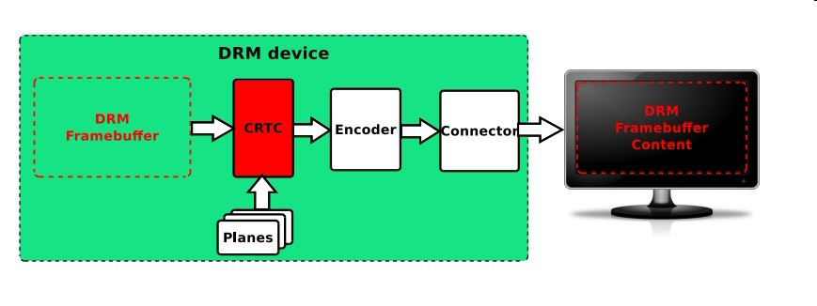

Let's focus on the five blocks in the green box together.

**2.1 DRM Framebuffer**

It is a memory area, I understand it as a canvas, which can be accessed by both the driver and the application layer. Before painting, it needs to be formatted. We need to set whether you want to paint oil painting or Chinese painting (**color mode, such as RGB24, YUV, etc**.), and how large the canvas needs to be **(resolution).**

What is a canvas in graphics?

In computer science and visualization, a canvas is a container that holds various drawing elements (lines, shapes, text, frames containing others elements, etc.). It takes its name from the canvas used in visual arts.

**2.2 CRTC**

Literally translated as cathode camera context. I would say what it does is read the pixel data of the current scan buffer and generate video mode timing signals from it with the help of a PLL circuit. You might just start muttering and complaining about what the hell. Simple, the way of speaking is simple, in simple terms he is the context of the display output, I understand it as a scanner. It connects the Framebuffer address internally and the Encoder externally.

**It will scan the content on your canvas (Framebuffer), overlay the content of Planes, and pass it to the Encoder.**

**2.3 Planes**

Literally translated as plane**. It is the same memory address as the framebuffer.** What does it do? Imagine a scene where the author is writing an article while watching an action blockbuster very inattentively. Every frame of an action blockbuster has a lot of changes and needs to be updated in full. It is impossible to squeeze a word out of writing an article for a long time, and basically no update is required. The author's naughty pulls the use of graphics cards to two extremes. **One is the Video Mode with full-frame high-speed update, and the other is the Graphics Mode with a small range of text interaction. Now it's the turn of Planes, which provides a high-speed channel for Video refresh, making Video a separate layer, which can be superimposed on or below Graphic, and has functions such as zooming.**

Looking at the picture at the beginning of this section**, there can be multiple Planes, so the last picture (image) scanned by the scanner (CRTC) is actually a combination of Framebuffer and Planes (Blending).**

**2.4 Encoder**

Literally translated as encoder**. Its function is to encode (convert) the pixels of the memory into the signals required by the display.**

You can think of its role as if you want to display your painting on different Display Devices all over the world, **you naturally need to convert it into different electrical signals, such as DVID, VGA, YPbPr, CVBS, Mipi, eDP, etc.**

**So we need such an Encoder for signal conversion**. The interaction between it and CRTC is what we call ModeSetting, which includes the color mode provided earlier, as well as timing (Timing).

**2.5 Connector**

Literally translated as connector. Connector usually corresponds to a physical connector (VGA, DVI, FPD-Link, HDMI, DisplayPort, S-Video …) It will connect a physical display output device (monitor, laptop panel, …).

Information related to the currently physically connected output device (such as connection status, EDID data, DPMS status or supported video modes) is also stored within the Connector.

**3. Features in DRM**

3.1 GEM

Graphics Execution Manager

Graphics APIs such as OpenGL continue to become more complex as the video memory size increases. Reinitializing the graphics card state on context switches can be quite expensive. Also, now the Linux desktop needs an optimal way to share the offscreen cache with the composition manager.

These requirements led to the development of a new method to manage the graphics buffer area in the kernel, the GEM.

3.1.1 GEM memory management

GEM provides a set of APIs with explicit memory management primitives. With GEM, user-space programs can create, process, and destroy memory objects in GPU video memory. These objects are collectively referred to as "GEM objects", and from a user space perspective, they always exist, so they don't need to be reloaded when the program regains the GPU. **When a user-space program needs a lot of video memory space (to store framebuffer, texture data, or other data required by the GPU), it will use the GEM API to allocate memory for DRM Driver requests. This API also provides functions for filling and releasing buffers. And can release the associated memory when the user space process (due to accidental or normal termination) closes the DRM device descriptor.**

GEM also provides methods for two or more user-space processes to access the same DRM device (ie, share the same GEM object). GEM provides a method, flink (in fact, this method is very unsafe), to get the GEM name from the GEM handle. A process passes the GEM name (32bit integer) to another process via IPC. The process that receives the GEM name can then obtain a local GEM handle to point to the original GEM object.

So if a malicious third-party application knows the GEM name, it can access and modify the contents of the GEM object. So later by introducing DMA-BUF mechanism to overcome this defect.

3.1.2 GEM memory synchronization

**Besides managing the video storage space, another important task of the video memory manager is to deal with the problem of memory synchronization between GPU and CPU.**

Because the current memory architecture is very complex, it usually involves multi-level caches of system memory and video memory. Therefore, the video memory manager is also responsible for handling cache coherency in order to ensure the coherence of the shared data between the GPU and the CPU. This means that the video memory management system is highly dependent on the GPU hardware and memory architecture and therefore driver specific.

GEM defines "memory domains" for memory synchronization, and these memory domains are not related to the GPU, they are designed with the UMA memory architecture, making it unsuitable for other memory architectures, such as those with separate VRAMs. Therefore, externally, the DRM driver will expose a unified GEM API to the user space, and internally, the driver will implement different memory managers that are more suitable for specific hardware and memory architectures.

3.2 KMS

Kernel Mode Setting

**In order to work properly, the video card and graphics adapter must be responsible for setting some modes, including screen resolution, color depth, refresh rate, etc., within the parameters supported by themselves or the extended screen. This action is mode-setting, and it usually requires access to graphics hardware -- the ability to manipulate the video card's registers.**

**Mode-setting is performed before starting to use the framebuffer, or when the mode is changed by the application or the user.**

3.2.1 UMS

Initially, userspaces that want to use the graphics framebuffer also need to be responsible for mode-setting, so they need access to the video hardware. **A good example is the Display Server on Unix-like systems such as the X Server, whose mode-settings are placed in the respective DDX driver for each specific graphics card.**

This approach, called UMS (User space Mode-Setting), has several serious problems. It not only breaks the isolation between hardware and programs established by the operating system, but also allows the hardware to produce inconsistent states when multiple processes perform mode-setting at the same time.

So in order to avoid these conflicts, X Server becomes the only user space program for real-time mode-setting, and other user space programs rely on X Server for mode-setting.

**Initially mode-setting is placed in the X Server startup process, but later it can also be mode-setting during its running process.**

But UMS has many problems.

For example, during the boot process of the Linux system, the Linux kernel must set the "minnimal text" mode for the virtual console.

**In addition, the framebuffer driver also contains the code to configure the framebuffer device mode.**

**To resolve these conflicts, some Display Servers (such as the X Server) save the mode-setting state when switching from a graphical environment to a text virtual console, and restore it when switching back.**

**This leads to new problems, such as flickering when switching, display failure or even corruption of output devices.**

3.2.2 mode-setting

**In order to solve these problems, mode-setting is put into the Kernel alone, to be precise in the DRM module.**

**Then, each process, including the X Server, can instruct the kernel to implement mode-setting operations, and the kernel will ensure consistency of operations. The mode-setting operations performed by these new kernel APIs and code added to the DRM module are called KMS .**

It has so many benefits,

1. **the first being that it gets rid of the repetitive mode-setting code from the Kernel (console, fbdev) and Userspace (X Server DDX Driver).**
2. **The second is that the graphics operating system no longer needs to care about the writing of the mode-setting part of the code.**
3. **The third is that because this single centralized mode management is provided, it becomes easier to switch between different instances of the console and X Server.**
4. **The fourth is that after the mode-setting is put into the kernel, it can be used from the boot process (this used to cause flickering problems).**
5. **In addition, because KMS is part of the kernel, it can also use many resources of the kernel space (such as interrupts). Mode recovery after suspend/resume is simpler because it is left to the kernel to manage. The kernel also makes it easier to hot-plug new display devices.**

**Since mode-setting is closely related to memory management -- framebuffer is basically a memory buffer -- it is tightly integrated with image memory management.** This is also the reason why it is placed in the DRM module instead of being a separate subsystem.

3.2.3 KMS Driver

In order not to break the backward compatibility of the DRM API, KMS provides a special feature for the DRM Driver. Any DRM Driver needs to choose whether to use the DRIVER\_MODESET flag when registering the DRM Core to indicate whether to support the KMS API.

Drivers that support KMS API are often called KMS Drivers to distinguish them from traditional DRM Drivers.

3.2.4 KMS Device Mode

The KMS is responsible for shaping and managing output devices, abstracting them into a series of hardware modules (often on the display controller's display output pipeline).

**We have introduced these modules before, CRTC, Planes, Encoder, Connector. But the introduction at that time was relatively popular. The following is the Google translated version on Wikipedia:**

**CRTCs: Each CRTC (from the CRT controller) represents the scan engine of the display controller and points to the framebuffer. The goal of the CRTC is to read the pixel data of the current scan buffer and generate video mode timing signals therefrom with the aid of a PLL circuit.**

**The number of CRTCs determines how many independent output devices the hardware can handle simultaneously, so in order to use a multi-head configuration, you need at least one CRTC per display device.**

**Two or more CRTCs can also work in clone mode, sending the same image to multiple output devices if they scan the same framebuffer.**

**Connectors:** Connectors represent where the display controller sends the video signal from the scanout operation to be displayed.

Usually, Connectors in KMS correspond to physical connectors

(VGA, DVI, FPD-Link, HDMI, DisplayPort, S-Video …) and it will connect a physical display output device (monitor, laptop panel, …).

**Information related to the currently physically connected output device (such as connection status, EDID data, DPMS status, or supported video modes) is also stored within the connector.**

**Encoders:** The display controller must encode the video mode timing signal from the CRTC using a format suitable for the intended connector. An encoder represents a block of hardware capable of performing one of these encodings. **Connectors can only receive signals from one encoder at a time, and each type of connector supports only a few encodings. There may also be other physical limitations, not every CRTC is connected to every available encoder, limiting the possible combinations of CRTC encoder connectors.**

Planes: planes are not hardware blocks, **but memory objects that contain buffers supplied to the scan engine (CRTC). The plane that holds the framebuffer is called the main plane, and each CRTC must have an associated plane because it is the source of the parameters that the CRTC determines. Parameters include, video mode - display resolution (width and height), pixel size, pixel format, refresh rate, etc.**

Four, component framework

The DRM of the RK platform also relies on the component framework .

Here is the discussion on the RK Socs DRM Driver Patch on the kernel mailing list: https://lkml.org/lkml/2014/12/2/161

At the beginning of the email we can see that the birth of the RK platform DRM Driver depends on the major changes in 15 versions.

One of the most important points mentioned is that it uses the component framework.

Since there are many devices mounted under DRM, the boot sequence may cause problems:

The driver generates a probe deferral because it waits for the preparation of another resource, resulting in an indeterminate order.

If the sub-device is not loaded properly, the main device is loaded, causing the device to fail to work.

The sub-devices may have a timing relationship with each other, and the indeterminate loading order may cause the device to work sometimes and sometimes not.

Now the kernel is compiled with multi-threading, and the order of compilation will also affect the loading order of the driver.

For the RK platform, because multiple VOPs are used, it is necessary to start the probe of the DRM Driver after all the VOPs are started, that is, to postpone the probe.

At this time, a unified management mechanism is needed to integrate all the devices and load them in a unified order. After all the components are loaded, bind them to the master.

For a more detailed article introducing components, refer to the process of component authors discussing the component framework with others:

https://patchwork.kernel.org/patch/3431851/

Our exposure to components will stop at the component part of the drm master probe. We will analyze the main logic of the component in the rockchip drm master probe with a separate section in the analysis of the drm driver code in the next chapter.

Reference article

wikipedia drm: https://en.wikipedia.org/wiki/Direct\_Rendering\_Manager

landley drm: http://www.landley.net/kdocs/htmldocs/drm.html

ubuntu drm kms: http://manpages.ubuntu.com/ manpages/zesty/en/man7/drm-kms.7.html

https://lkml.org/lkml/2014/12/2/161

https://patchwork.kernel.org/patch/3431851/

# Linux DRM subsystem, Linux DRM things - basic concepts

1. Introduction to DRM

In the Linux kernel, the graphics adapter's framebuffer can be managed using fbdev's [API , but it cannot handle the 3D acceleration capabilities of modern GPU-based graphics cards.](https://so.csdn.net/so/search?q=API&spm=1001.2101.3001.7020)DRM is a subsystem of the Linux kernel, originally developed as a kernel-space component of the X Server DRI, and subsequently used in other graphics stacks (such as Wayland). DRM is responsible for interacting with the GPU interface of modern graphics cards. **User programs can use the API provided by DRM to send commands and data to the GPU to implement operations such as display mode settings, GPU hardware-accelerated 3D rendering, video decoding, and GPGPU (general-purpose GPU) computing. .**

2. Introduction of nouns

The following table introduces some of the nouns involved in the DRM [framework :](https://so.csdn.net/so/search?q=%E6%A1%86%E6%9E%B6&spm=1001.2101.3001.7020)

abbreviation

full name

explain

DRI

Direct Rendering Infrastructure

base layer direct rendering

DRM

Direct Rendering Manager

Direct Render Manager

FBDEV

Framebuffer Device

frame buffer device

GEM

Graphics Execution Manager

Graphical Execution Manager

KMS

Kernel Mode Setting

Kernel display mode settings

UMS

User-space Mode Setting

User space display mode settings

V4L2

Video For Linux 2

linux video device driver

3. DRM framework

**The Linux DM framework consists of two parts: DRM core and DRM driver. DRM core implements the basic framework of DRM, can register DRM driver, and provides a set of ioctls for user space. DRM driver mainly implements some hardware drivers such as CPU/**[**GPU**](https://so.csdn.net/so/search?q=GPU&spm=1001.2101.3001.7020)**that it supports , and provides ioctl implementation not covered by DRM core or extended (only available on such hardware). User space programs can use libdrm to access various interfaces of the DRM framework.**

Since only libdrm and Linux DRM have been debugged in the actual project, these two parts will be introduced first. The following figure is excerpted from the network and introduces the DRM framework.

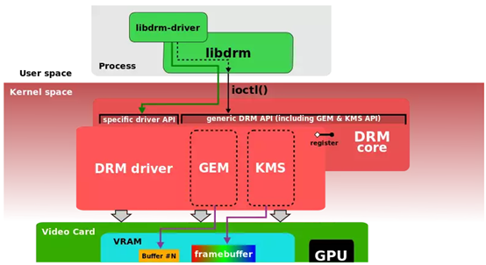

# Introduction to DRM in Linux

DRM in Linux

DRM - Direct Rendering Manager

DRM code location

DRI - Direct Rendering Infrastructure

How DRM supports DRI

1. DRM provides simultaneous access to graphics card hardware.

2. When DRM accesses the graphics card hardware, it enforces the DRI security test policy.

DRM provides a generic DMA engine.

DRM and DRI relationship

from

DRM in Linux

In the Unix-like world, there is also a DRM, The Direct Rendering Manager, which is a component of the DRI (Direct Rendering Infrastructure) framework. The role of DRI is to provide efficient video acceleration for Unix-like systems (a very important use is to provide acceleration effects for 3D rendering).

DRI is composed of the following two parts (these two can be compiled into the kernel in linux, or can exist in the form of modules):

1. General DRM driver.

2. Drivers that support specific graphics cards.

DRM - Direct Rendering Manager

DRM is a kernel-level device driver that can either be compiled into the kernel or loaded as a standard module. DRM first appeared in FreeBSD and was later ported to Linux systems and became a standard part of Linux systems.

DRM can directly access the hardware of DRM clients. The DRM driver handles DMA , memory management, resource locking, and secure hardware access. To support multiple 3D applications simultaneously, the 3D graphics card hardware must act as a shared resource, thus requiring locks to provide mutually exclusive access. The DMA transfer and AGP interface are used to send buffers for graphics operations to the graphics card hardware, so it is necessary to prevent clients from unauthorized access to the graphics card hardware.

The Linux DRM layer is used to support those complex graphics devices that usually contain programmable pipelines that are ideal for 3D graphics acceleration. The DRM layer in the kernel makes it easier for these graphics card drivers to perform memory management, interrupt handling and DMA operations, and can provide a unified interface for upper-layer applications.

DRM code location

Because the internal interface and data structure of the Linux kernel may change at any time, the DRI module needs to be compiled for a specific kernel version. For versions after kernel 2.6.26, the DRM (DRI kernel module) source code is stored in kernel/drivers/gpu/drm; in versions before this, the source code is in the kernel/drivers/char/drm directory.

Each 3D hardware acceleration driver contains a kernel module and requires DRM support code.

DRI - Direct Rendering Infrastructure

DRI is not a software module. Instead DRI is composed of a series of software modules. The purpose of introducing DRI is for 3D graphics acceleration. DRI is a software architecture that coordinates the work between the linux kernel, the X windows system, the 3D graphics hardware and the OpenGL rendering engine.

How DRM supports DRI

DRM supports DRI in three ways

1. DRM provides simultaneous access to graphics card hardware.

A direct rendering system has multiple entities (such as the X server, multiple direct-rendering clients, and the kernel) competing for access to graphics hardware. PC-like graphics cards use locks when multiple entities access the graphics card hardware. DRM provides a lock for each graphics device to synchronize hardware access. For example, when the X server is performing 2D rendering, the direct-rendering client executes a software callback that reads and writes the frame buffer. For some high-end cards, this lock is not required because the hardware itself will sequence the access commands.

2. When DRM accesses the graphics card hardware, it enforces the DRI security test policy.

The X server runs with root privileges, and when accessing the framebuffer and MMIO areas of the graphics card, these areas are mapped with /dev/mem. A direct-rendering client, which does not run as root, but still requires a similar mapping. The DRM device interface allows clients to create these mappings, subject to the following restrictions: \* These areas can only be mapped when the client is connected to the X server, which forces direct-rendering clients to obey the normal X server security policy. \* These areas can only be mapped if the client can open /dev/drm?. This allows system administrators to configure direct rendering access that only trusted users can access. \* Clients can only map areas that are allowed by the X server.

DRM provides a generic DMA engine.

The graphics hardware of most modern PC-like computers provides DMA access to the command FIFO. DMA access has better throughput performance than MMIO access. For these graphics cards, the DMA engine provided by DRM includes the following features: \*

DRM and DRI relationship

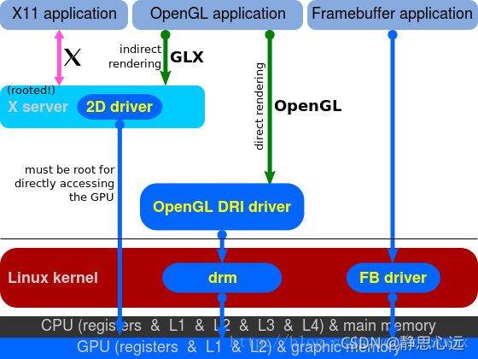

In the current Direct Rendering Infrastructure,

we can see that DRM is an integral part of DRI, and DRI also includes kms and OPenGLES DRI driver.

from

Introduction to DRM in Linux

The knowledge points of the article are matched with the official knowledge files, which can further learn related knowledge

CS introductory skill treeGetting Started with Linux806 people who are new to Linux are learning the system

# Understanding Linux DRM

This article introduces the following parts:

1. Introduction to DRM Concepts

2. Comparative HW structural analysis

3. code analysis

1. Introduction to DRM Concepts

DRM is an acronym for Direct Render Manager:

Linux Display Subsystem Architecture Framework

Provide standard API upwards for application use

Manage GPU and Display modules

Compared with the original framebuffer structure, **DRM abstracts and manages more hardware modules, so it is more flexible and convenient;**

Contains the following modules:

GEM (Graphics Execution Manager) is used to manage the application and release of display buffers

DUMB: Only supports contiguous physical memory, based on the underlying CMA memory management implementation of Linux, mostly used in small resolution scenarios

PRIME: can support continuous & non-contiguous memory, based on DMA-BUF mechanism, can realize buffer sharing, mostly used in large memory complex scenarios

**FENCE: buffer synchronization mechanism, implemented based on dma\_fence, to solve the phenomenon of tearing, frame shaking, frame return and other phenomena that occur when buffer control is not synchronized**

**KMS (Kernel Mode Sstting) is used to set display related configuration, display screen**

**Hardware module division**

**CRTC: Configure parameters such as timing and resolution**

**ENCODER: A module that converts data data to output data format**

**Connector: Connector, display data transmission module, such as LVDS TX / MIPI DSI / HDMI**

**Panels: The physical screen also includes the Overlay layer in the hardware module;**

Other related concepts

**framebuffer: Displays the data in the buffer, generally the data rendered by the GPU or the input data of the camera;**

**VBLANK: The synchronization signal is displayed in the DRM frame, which is triggered by the vsync signal in the DPU;**

**page flip: The data filling in the current framebuffer has been completed, and the display signal can be sent;**

property: a general configuration item in the drm framework, used to supplement the content information that cannot be included above'

As shown in the figure, compared with the original FB structure, the DRM device structure abstracts the related hardware modules out of objects for management, and can be configured more flexibly

2. Comparative HW structural analysis

Here is the general frame structure of a display module :

The above image only depicts the data path (the control part is not added):

DPU reads data from framebuffer

The output is sent to the LVDS Encoder module after processing such as controlling synthesis scaling

The Encoder module converts the data into physical line signals and sends them to the PHY for output;

It can be seen that the data output path is: DPU – LVDS – TX, which can be in one-to-one correspondence with the abstract concepts in DRM:

CRTC corresponds to DPU

Encoder corresponds to LVDS Encoder

Connector corresponds to PHY or line, does not involve too much control, and can not be specially reflected in the code

Let's look at the internal structure of the DPU in detail:

The Display Engine contains the Overlay module we described earlier, as well as the synthesis module that follows;

Configure Display timing related configuration in Output Engine;

Support rotation, scaling, PQ and other processing;

This part of the hardware support function can flexibly add control in DRM;

3. code analysis

First look at the DRM Architecture diagram on Wikipedia:

Implement the libdrm library to provide a standard API at the user layer to operate the DRM device, and obtain the various components (CRTC, Connector, Encoder)

Implement core management in the kernel layer:

Docking the upper libdrm structure

Provide a registration interface, and register crtc, encoder, connector, etc. through such interfaces when drv is actually implemented

The ioctl corresponding to the physical device operation is also linked with the actual drv

GEM management in the kernel

# linux drm architecture

Reprinted from:

http://manpages.ubuntu.com/manpages/utopic/man7/drm-kms.7.html

To paraphrase according to your own understanding:

Summary:

DRM is a graphics rendering architecture (Direct Render Manager) under [linux](https://so.csdn.net/so/search?q=linux&spm=1001.2101.3001.7020" \t "_blank) , specifically a graphics card driver architecture (how does the driver play? The function is encapsulated into standard interfaces such as open/close/ioctl, and the application calls these interfaces to drive the device. ).

As a graphics card, the most basic function is to output the user's drawing to the display screen. How does DRM implement it? Let's first take a look at the basic elements that DRM summarizes "this matter" for you:

Canvas (FrameBuffer), Drawing Field (CRTC), Output Converter (Encoder), Connector (Connector), and then to the display

**1 Canvas (FrameBuffer)**

For computers, FrameBuffer is a piece of memory that can be accessed by both the driver and the application layer. Of course, there must be a certain format before drawing. For example, I can specify what color mode (RGB24, I420, YUUV, etc.), resolution How big is it, and what parameters are there, then you have to go to the drawing site to see :p

**2 Drawing Field (CRTC)**

The abbreviation translates to the context of the negative camera tube. In DRM, CRTC means the context of the display output. First, CRTC refers to a FrameBuffer address, and an Encoder is connected to it. How do they communicate with each other? This is what the display mode (ModeSet) has to do. ModeSet includes the color mode mentioned above, and the timing of the display (timings, ModeLines, etc. all represent this meaning), etc. Usually the timing can be expressed as follows

PCLK  HFP  HBP  HSW  X\_RES  VFP  VBP  VSW  Y\_RES

Pixel Clock  Horizontal Front Retrace  Horizontal Retrace  Horizontal Sync Head  Horizontal Effective Length  Vertical Front Retrace  Vertical Back Retrace  Vertical Sync Head  Vertical Effective Length

A CRTC can be connected to multiple Encoders, what are they used for, and realize the function of copying the screen.

**3 Output converter (Encoder)**

Thinking about the CRT is complicated enough. Our graphics cards are very capable and can be connected to various devices. Obviously, different signal converters are required for the output to convert the pixels of the memory into the signals required by the display (DVID, VGA). , YPbPr , CVBS etc...)

**4 Connector (Connector)**

Not referring to the physical wire, back to DRM which is an abstract data structure representing the connected display device, from here we can get the EDID of the device, DPMS connection status, etc.

**5 Display plane (Planner)**

Hey, how come there is one more. I am also very bored, the above stuff is not enough to work? In fact, many innovations often stem from people's dissatisfaction with the real world. You need to learn words, watch movies and play games, and you can watch movies while chatting. Two concepts are opposed here, the Graphics mode for small-scale updates such as text interaction, and the Video mode for fast full-frame updates. These two modes bring the use of graphics cards to two extremes.

So the concept of Planner has played a very good role, it provides a green channel for video refresh, and sometimes it is not mixed with graphics, sometimes it is a new layer (or overlay), which can be superimposed on Graphic or Below, you can also zoom...

The document says that the Planner is also on the FrameBuffer. It doesn't matter. Here we see that the stuff to be displayed in the CRTC should be a blending.

After understanding the concept, the next article will analyze the specific data structure and interface.

Reference documentation:

http://manpages.ubuntu.com/manpages/utopic/man7/drm-kms.7.html

http://events.linuxfoundation.org/sites/events/files/lcjpcojp13\_pinchart.pdf

http://landley.net/kdocs/htmldocs/drm.html

http://events.linuxfoundation.org/sites/events/files/slides/brezillon-drm-kms.pdf

http://elinux.org/images/7/71/Elce11\_dae.pdf

# The principle and application of linux drm

Reference link

dma:https://blog.csdn.net/abc3240660/article/details/81942190#t6

Linux DRM KMS 驱动简介:https://blog.csdn.net/zhuyong006/article/details/80942777

DRM（Direct Rendering Manager:https://blog.csdn.net/hexiaolong2009/article/details/83720940

**Application scenarios**

The linux drm (Direct Rendering Manager) was originally designed as a set of display data transmission process, which is used to throw the video data collected by the camera to the display for display.

An intermediate layer libdrm is encapsulated between the drm driver and the application. The application can operate the drm driver by calling the interface provided by libdrm , which is relatively simple.

**main module**

The drm system is mainly divided into three modules: libdrm, GEM, and KMS.

**libdrm**

libdrm runs in the user space and is a bridge between the application and the kernel. Its function is to fill in the structure required by the kernel and pass it into the kernel through ioctl calls. After the kernel is filled, it returns to the application space.

**GEM**

GEM (Graphic Execution Manager) is mainly responsible for buffer operations.

**KMS**

KMS (Kernel Mode Setting) is mainly responsible for the setting of relevant parameters (including resolution, refresh rate, power state (sleep wake-up), etc.) and switching of the display screen (switching of the display buffer, multi-layer synthesis method, and each image display position of the layer).

**fundamental element**

**KMS**

**1. CRTC: A hardware module that scans the display buffer and generates timing signals, usually referred to as Display Controller;**

a) DPMS (Display Power Manage System) power state management (crtc\_funcs->dpms)

b) Converting Framebuffer to standard LCDC Timing is actually a process of refreshing a frame of image (crtc\_funs->mode\_set)

c) Frame switching, that is, in During VBlank fading, switch Framebuffer (crtc\_funcs->page\_flip)

**2. Encoder: Responsible for converting the timing timing output from CRTC to what is needed by external devices**

a) DPMS (Display Power Manage System) power state management (encoder\_funcs->dpms)

b) Package the lcdc Timing output by the VOP into the corresponding interface timing HDMI TMDS / … (encoder\_funcs->mode\_set)

The encoder is the connector between crtc and connector

**3. CONNECTOR: The connector that connects the physical display device, such as HDMI, DisplayPort, DSI bus, usually bound with the Encoder driver, and is most closely related to the display;**

a) Get and report the hotplug status of the display

b) Read and parse the EDID information of the panel

**4. PLANE: Hardware layer, some Display hardware supports multi-layer composite display, but all Display Controllers must have at least one plane;**

a) plane is the connector between ctrc and framebuffer

b) each crtc must have at least one plane

c) Plane in DRM and plane in the YUV/YCbCr graphics format we often say are completely two different concepts. The plane in the YUV graphics format refers to the arrangement of image data in memory. Generally, the Y channel occupies a continuous memory block, and the UV channel occupies another continuous memory block. We call it YUV-2plane (also called YUV 2 plane). plane), which belongs to the software level. Plane in DRM refers to a single hardware layer module used for multi-layer synthesis in Display Controller, which belongs to the hardware level.

d) With the continuous updating of software technology, the performance requirements for hardware are getting higher and higher. Under the premise of use, the requirements for power consumption are becoming more and more stringent. Originally, the GPU can handle all graphics tasks, but because its power consumption is too high, the designers decided to hand over some simple tasks to the Display Controller (such as compositing), and let the GPU focus on drawing (ie rendering) This main task reduces the burden on the GPU, thereby achieving the purpose of reducing power consumption and improving performance. Thus, Plane (hardware layer unit) was born

**5. FB: Framebuffer is the display content of a single layer, the only basic element that has nothing to do with hardware**

a) The buffer is a piece of allocated memory, which has nothing to do with hardware. Generally, the buffer is associated with the data buf of the camera through the DMA\_BUF mechanism to achieve the purpose of fast data transfer

**6. property: Any parameter you want to set can be made into property, which is the most flexible and convenient Mode setting mechanism in DRM drivers**

a) The introduction of the Atomic mechanism can reduce the maintenance workload of the upper-layer application interface. When developers have new functions to add, they do not need to add new function names and IOCTLs. They only need to add a property in the underlying driver, and then get/operate the value of the property in their own applications.

b) Property The simple summary of the structure is mainly composed of three parts: name, id and value. The id is the globally unique identifier of the property in the DRM framework.

c) The flexibility of parameter setting is enhanced. One IOCTL can set multiple properties at the same time, reducing the number of switching between userspace and kernel space, and at the same time meeting the requirements of different hardware for parameter settings to the greatest extent, improving software efficiency

**GEM**

DUMB: A buffer type that only supports continuous physical memory. It is implemented based on the general CMA API in the kernel and is mostly used in simple scenarios with small resolutions.

PRIME: Both continuous and non-continuous physical memory are supported. Based on the DMA-BUF mechanism, buffer sharing can be realized, which is mostly used in complex scenarios with large memory.

fence: buffer synchronization mechanism, implemented based on the kernel dma\_fence mechanism, used to prevent asynchronous problems in the display content

**module behavior**

Taking the process displayed by HDMI Monitor as an example, the behavior of CRTC / Encoder / Connector under the example analysis

1. First, the HDMI driver detects the Plugin signal of the TV, reads the EDID signal of the TV, and obtains the resolution information of the TV (DRM Connector)
2. Userspace fills the framebuffer with the data to be displayed, and then informs the VOP device to start displaying through the libdrm interface
3. Then the VOP driver converts the data in the framebuffer into standard LCDC Timing timing (DRM CRTC)
4. At the same time, the HDMI driver aligns the LCDC timing configuration of the HDMI hardware module with the VOP output timing, and prepares to convert the input LCDC Timing into the HDMI TMDS signal (DRM Encoder) recognized by the TV.

# drm application call process

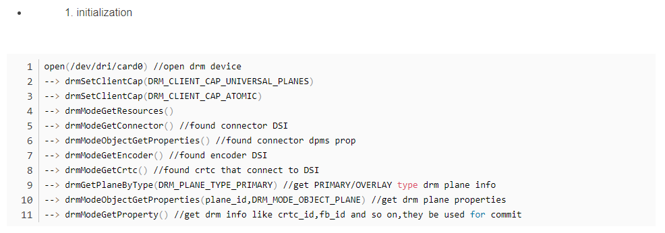

The order of obtaining crtc, encoder, connector, plane is connector, encoder, crtc, plane. Each structure of the former has the id number of the latter. After finding the connector, you can use the encoder\_id under its structure to find the one connected to yourself. The encoder module is the same until the connection path from the plane to the connector is found.

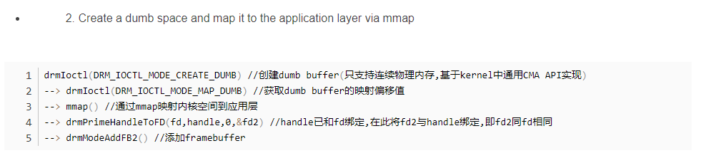

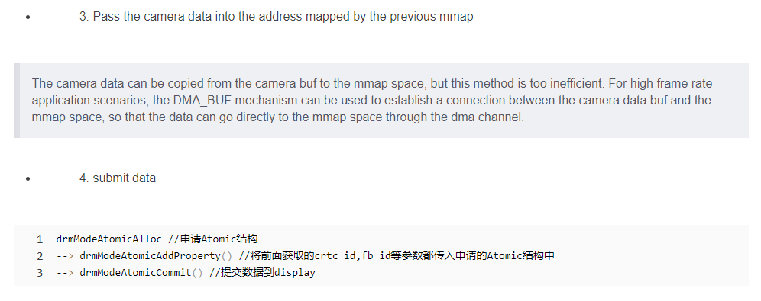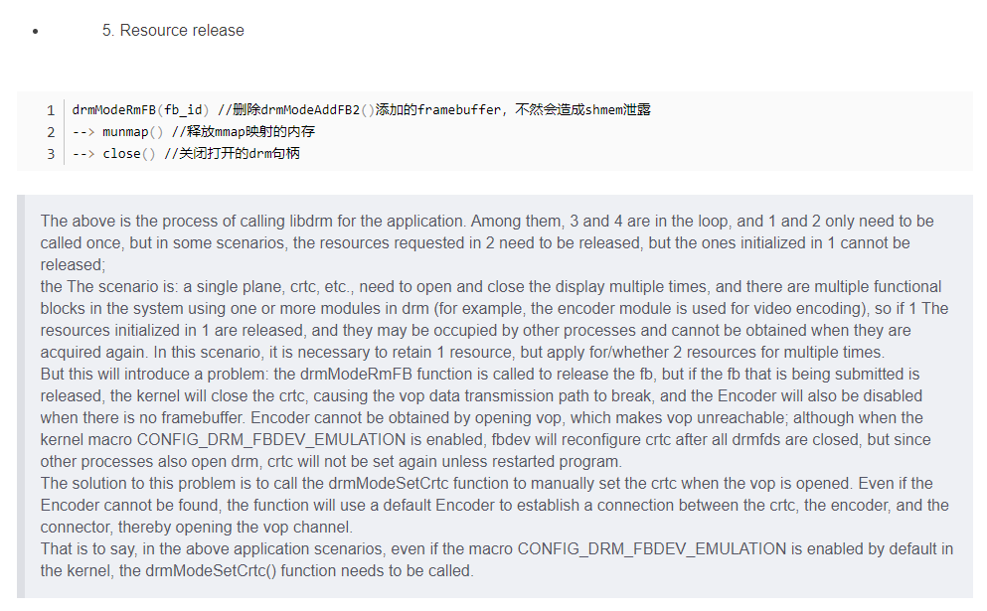

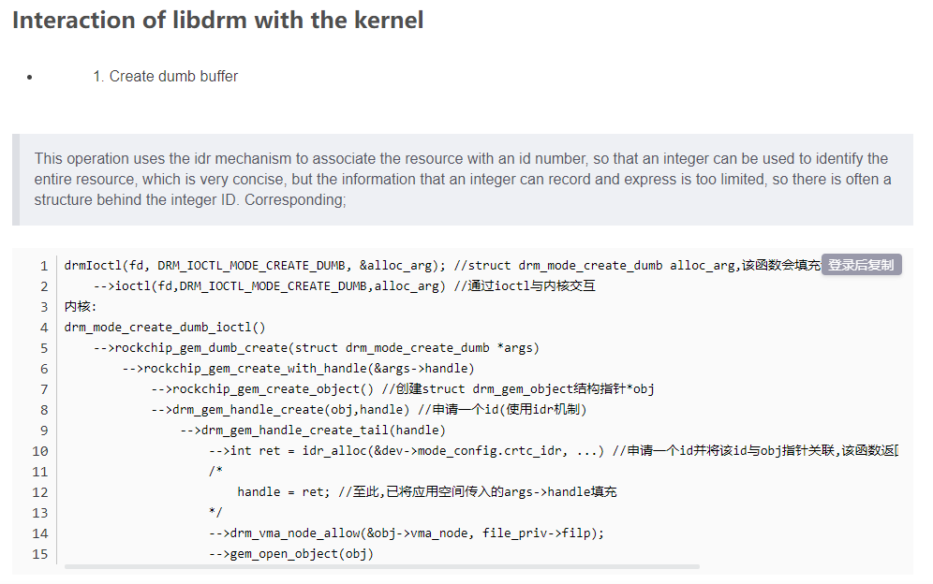

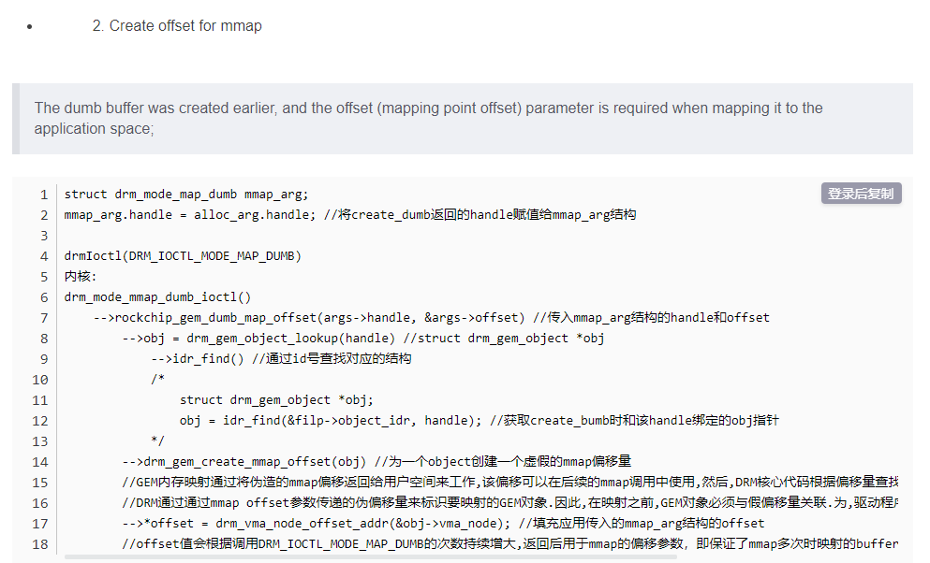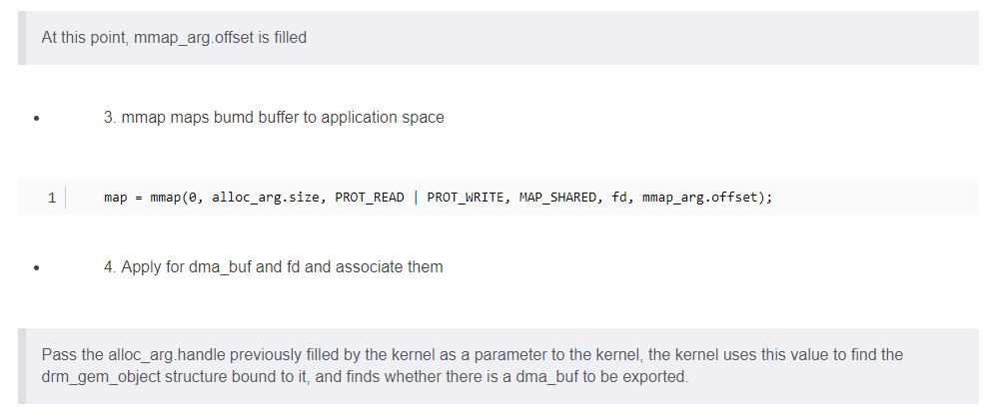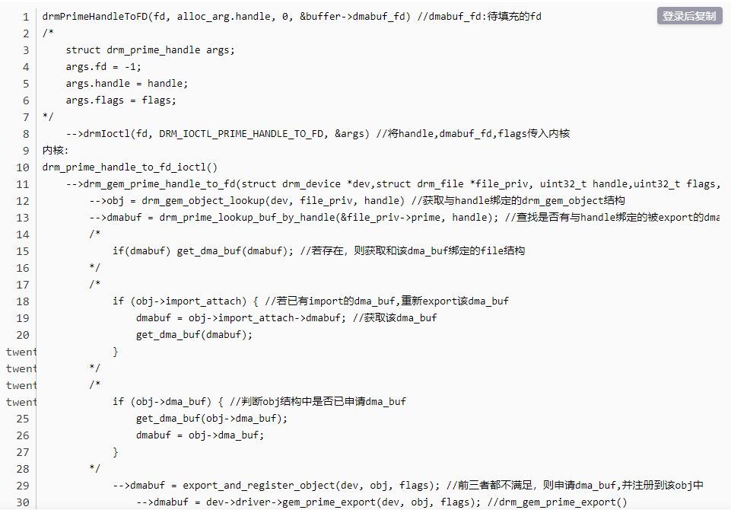

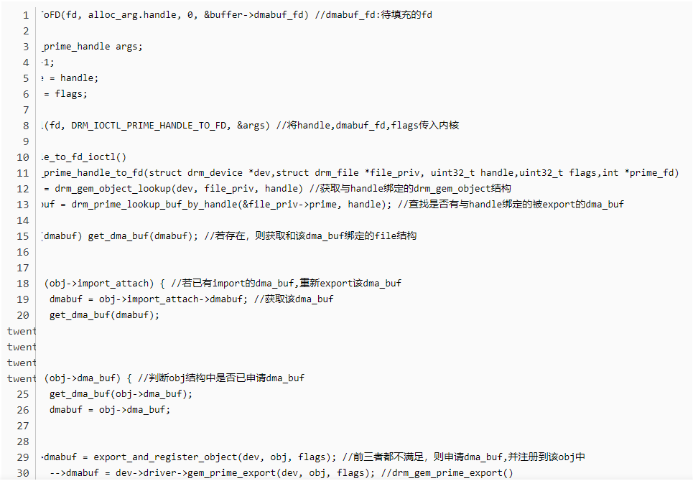

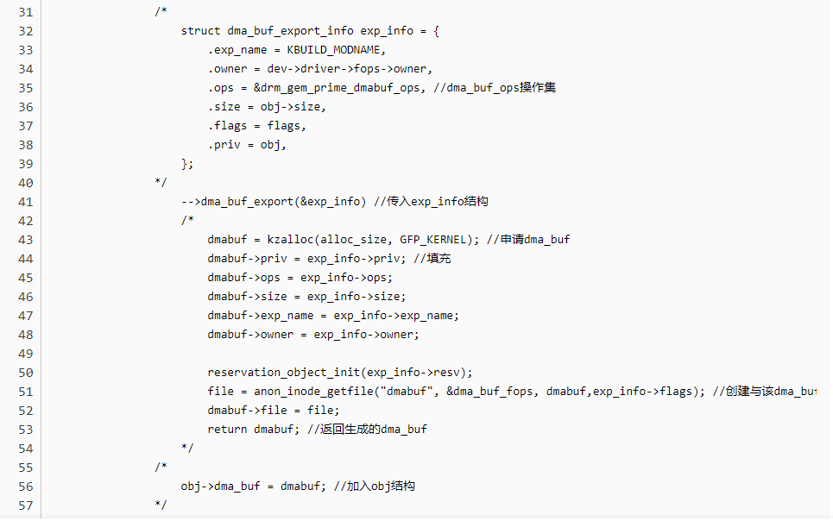

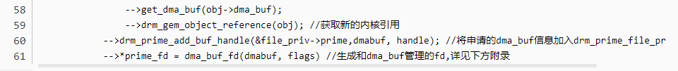

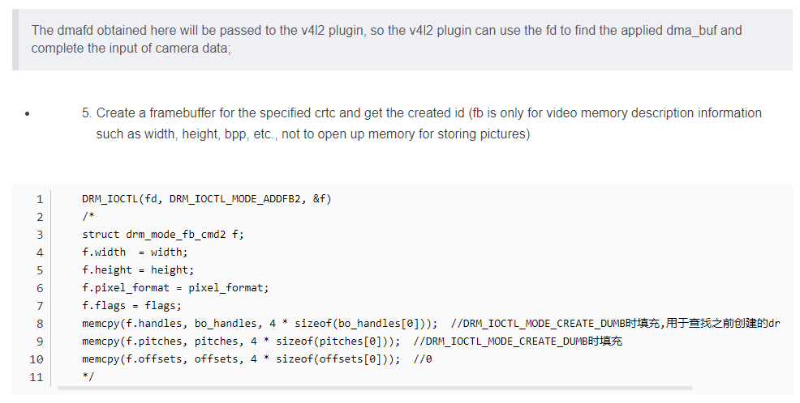

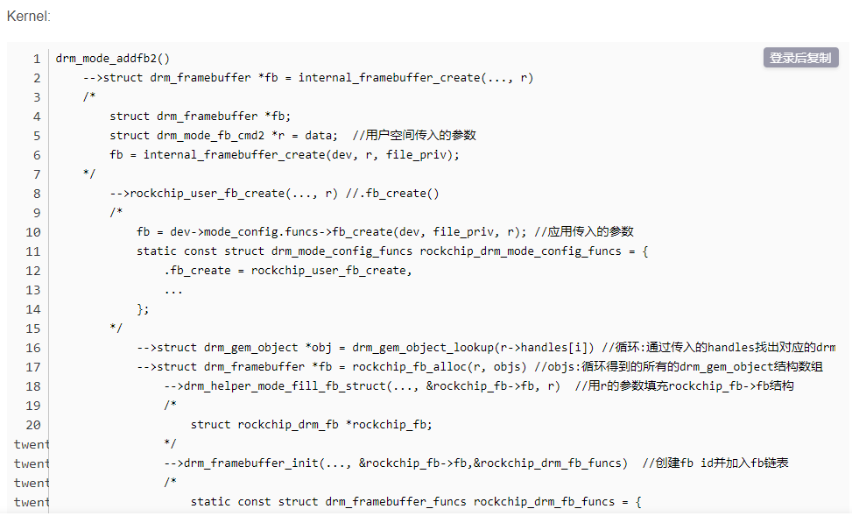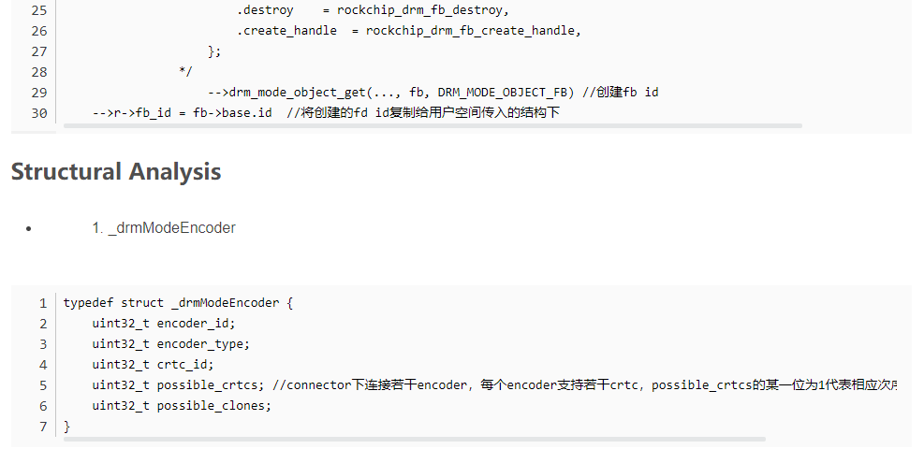

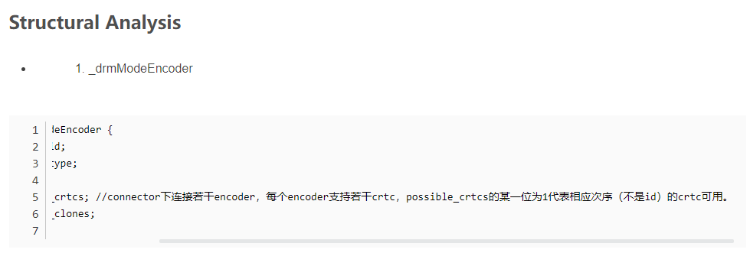

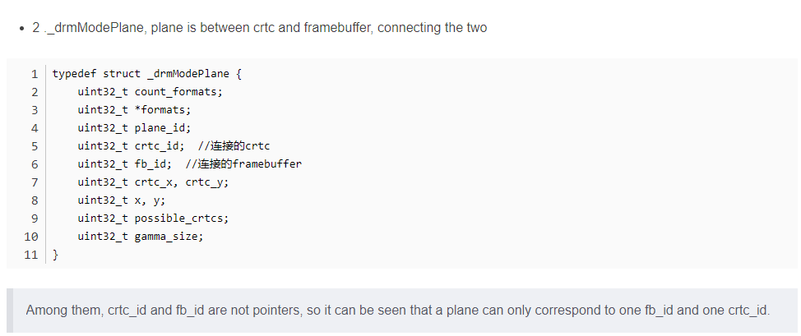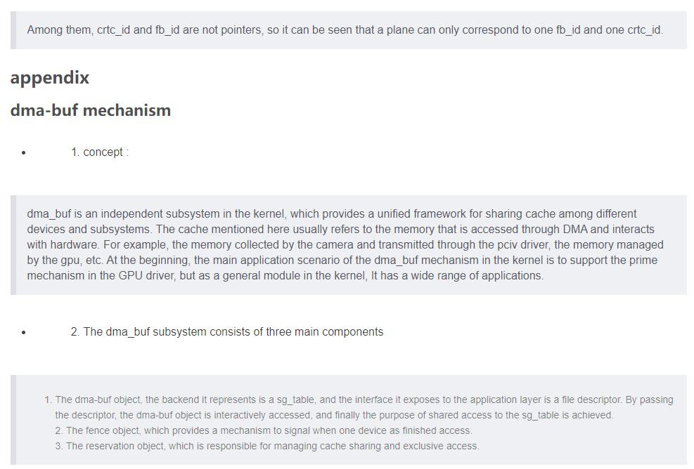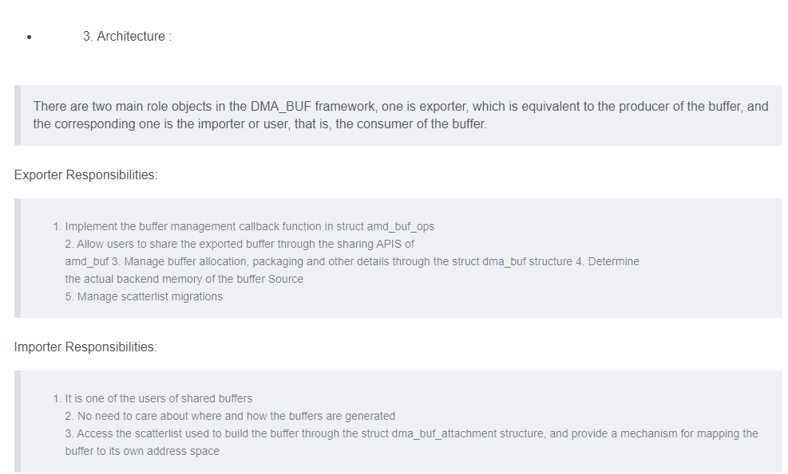

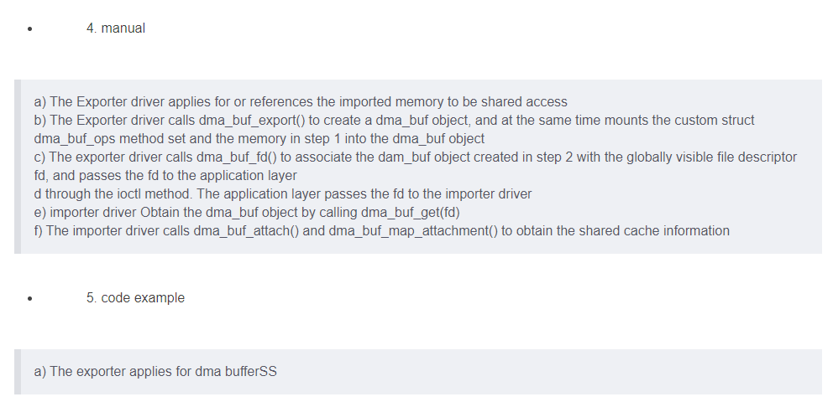

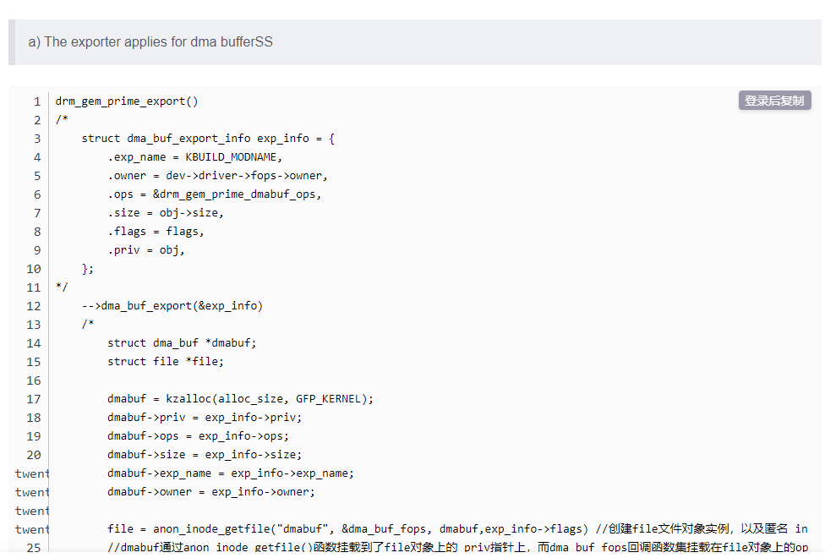

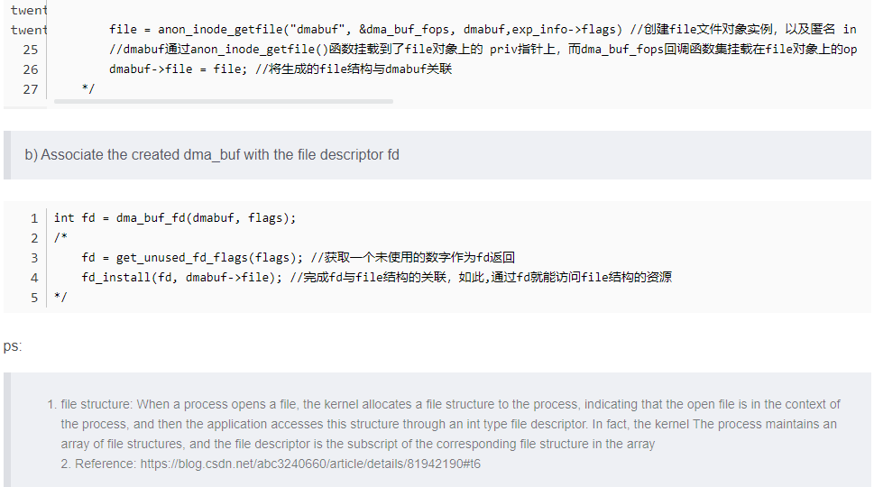

# Basic concepts and usage examples of Linux DRM (C language)

**I. Introduction**

In this week's work, in order to solve the customer's problem, I checked the source code in awtk-linux-fb, and I was very interested in the content about DRM in it. After consulting my colleagues, I checked the information on the Internet. This article summarizes the learning of DRM. , and practice the use of DRM in C language. I would like to thank my colleagues for answering my questions.

**2. What is DRM**

**DRM (Direct Rendering Manager) is the direct rendering manager .** It is produced to solve the problem of cooperative use of Video Card resources by multiple programs. It provides a set of APIs to user space for accessing and manipulating the GPU.

To put it simply, DRM is a graphics rendering architecture under Linux that manages display output and allocates buffers. Applications can directly manipulate DRM's ioctl or use the interface provided by framebuffer to perform display-related operations. Later, it was encapsulated into libdrm library, so that users can control the display more conveniently.

**3. Basic Concepts Included in DRM**

To understand how DRM outputs the user's drawing to the display screen, the following concepts cannot be avoided. The specific relationship is shown in the following figure:

**Framebuffer**

**CRTC**

**Encoder**

**Connector**

**Display Device(LCD)**

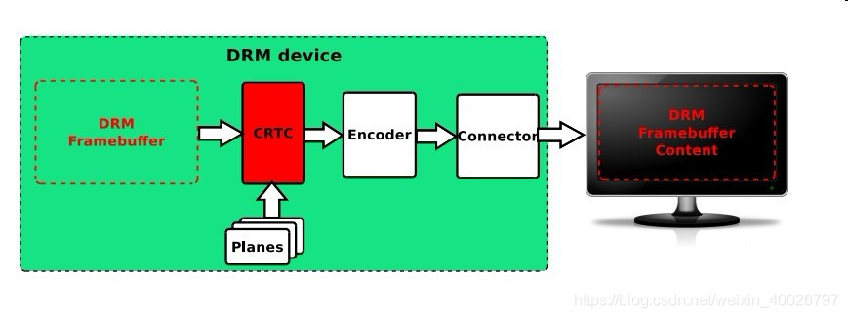

**3.1 DRM Framebuffer**

It is a memory area, which can be understood as a canvas, which can be accessed by both the driver and the application layer. Before drawing, you need to format it, set the color mode (such as RGB24, YUV, etc.) and the size (resolution) of the canvas.

**3.2 CRTC**

Cathode tube context. This name is very difficult to understand, but in simple terms, it is the context of the display output, which can be understood as a scanner. The CRTC connects the Framebuffer address internally and the Encoder externally. It scans the contents of the Framebuffer, superimposes the contents of the Planes, and finally transmits it to the Encoder.

**3.3 Planes**

flat. It is the same memory address as Framebuffer. What does it do? For example, on a computer, while typing and chatting on WeChat while watching a movie, two concepts are opposed here. Typing is a text interaction, which is a Graphics mode for small-scale updates; watching a movie is a full-frame high-speed update Video mode. These two modes The use of graphics cards has been pulled to two extremes.

At this time, Planes has played a very good role. It provides a high-speed channel for Video refresh, making Video a separate layer, which can be superimposed on or below Graphic, and has functions such as scaling.

There can be multiple Planes, which is equivalent to layer stacking, so the image scanned by the scanner (CRTC) is actually a combination (Blending) of Framebuffer and Planes.

**3.4 Encoder**

Encoder. Its function is to encode (convert) the pixels of the memory into the signals required by the display. The simple understanding is that if you need to display the picture on different devices (Display Device), you need to convert the picture into different electrical signals, such as DVID, VGA, YPbPr, CVBS, Mipi, eDP, etc.

The interaction between Encoder and CRTC is what we call ModeSetting, which includes the aforementioned color mode, timing, and so on.

**3.5 Connector**

Connector. It often corresponds to a physical connector (such as VGA, DVI, FPD-Link, HDMI, DisplayPort, S-Video, etc.), it does not refer to a physical cable, in DRM, Connector is an abstract data structure that represents a connected display device , the information related to the currently physically connected output device can be obtained from the Connector, such as connection status, EDID data, DPMS status, supported video modes, etc.

**Four, DRM use example (C language)**

According to the above, it can be known that DRM is a display driver framework, that is, it encapsulates functions into standard interfaces such as open/close/ioctl, and applications call these interfaces to drive devices and display data. The rest of this article will verify and use the DRM driver from the user's point of view.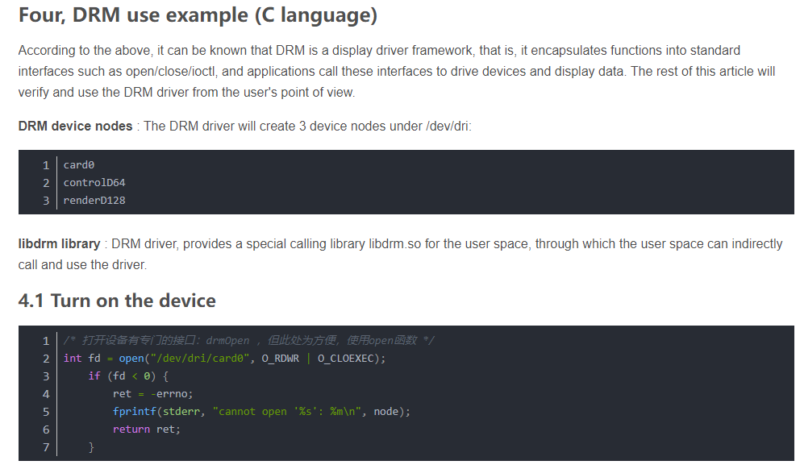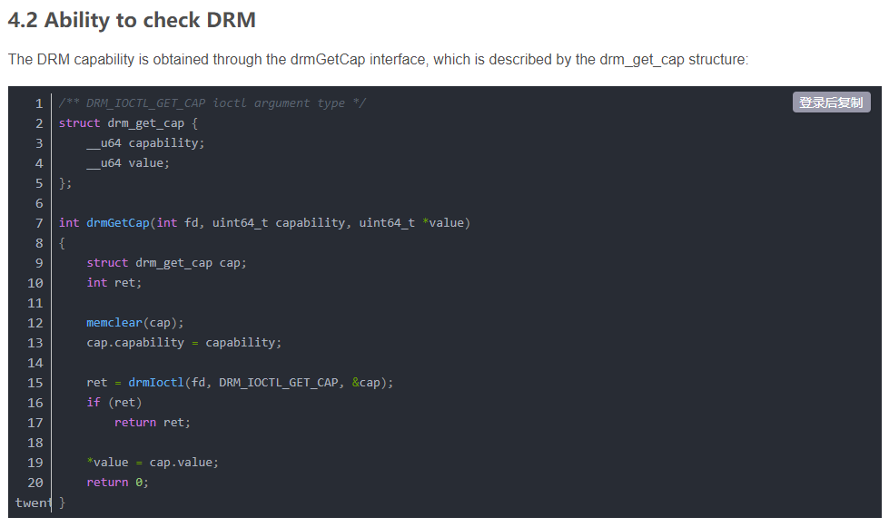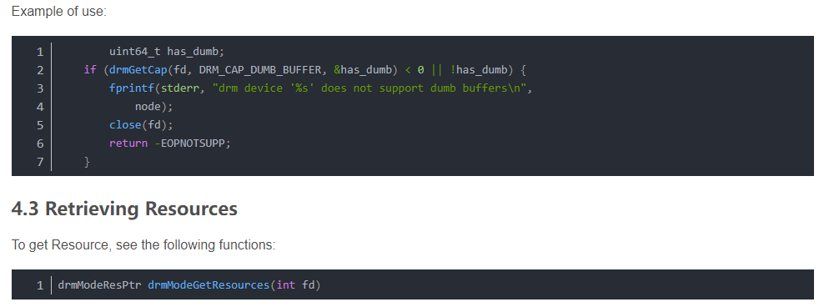

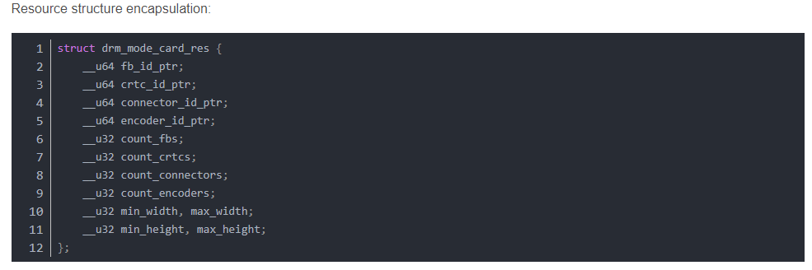

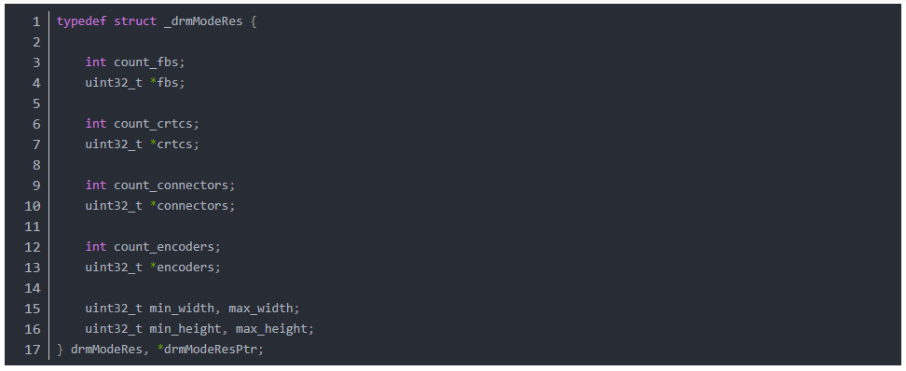

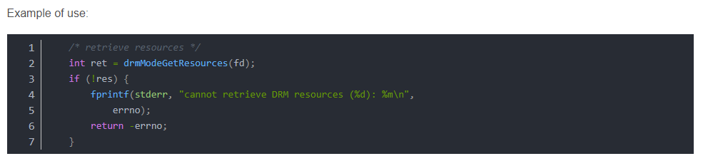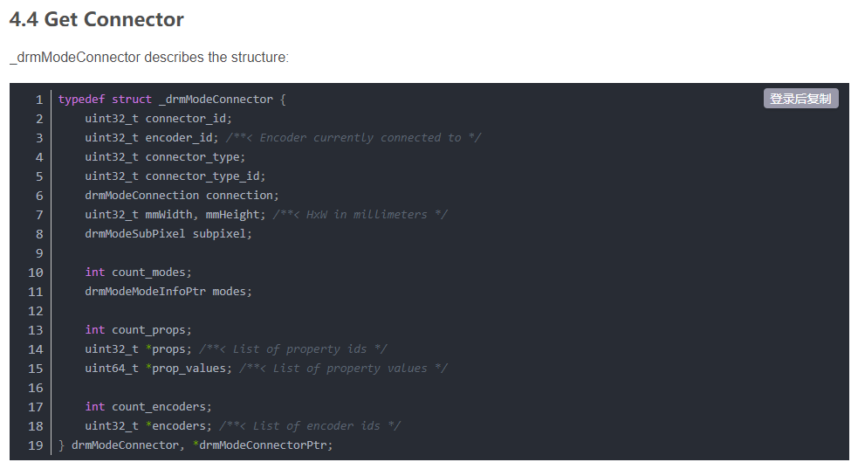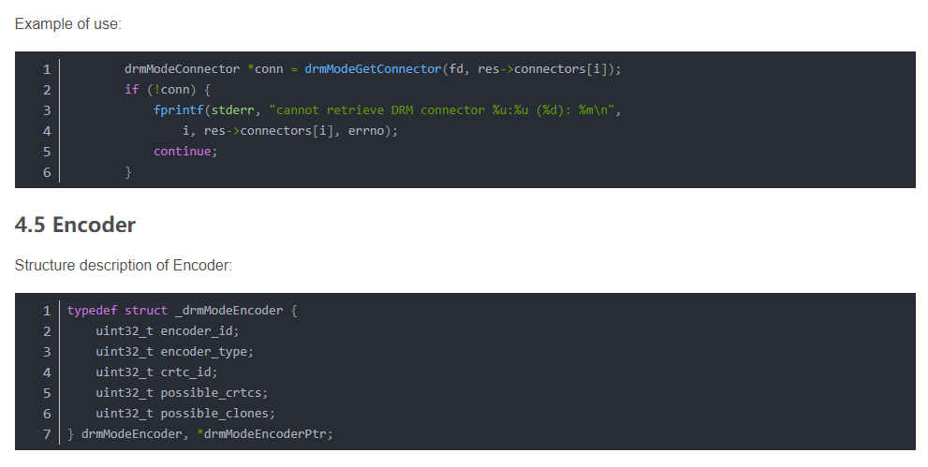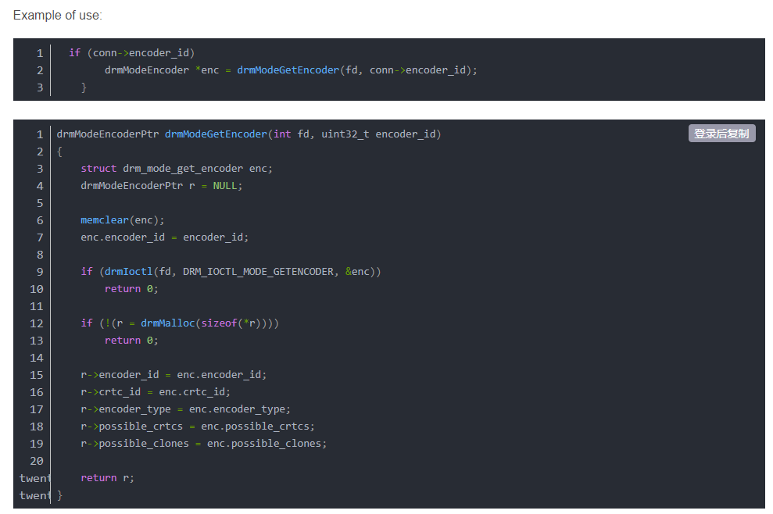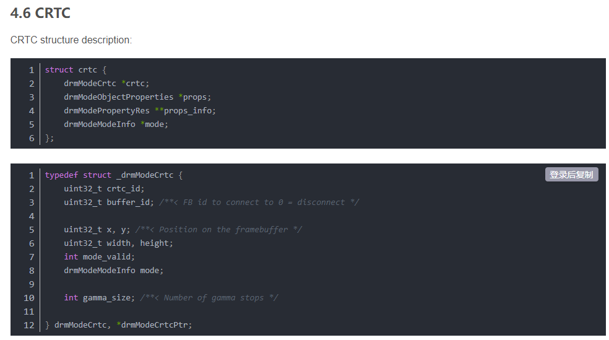

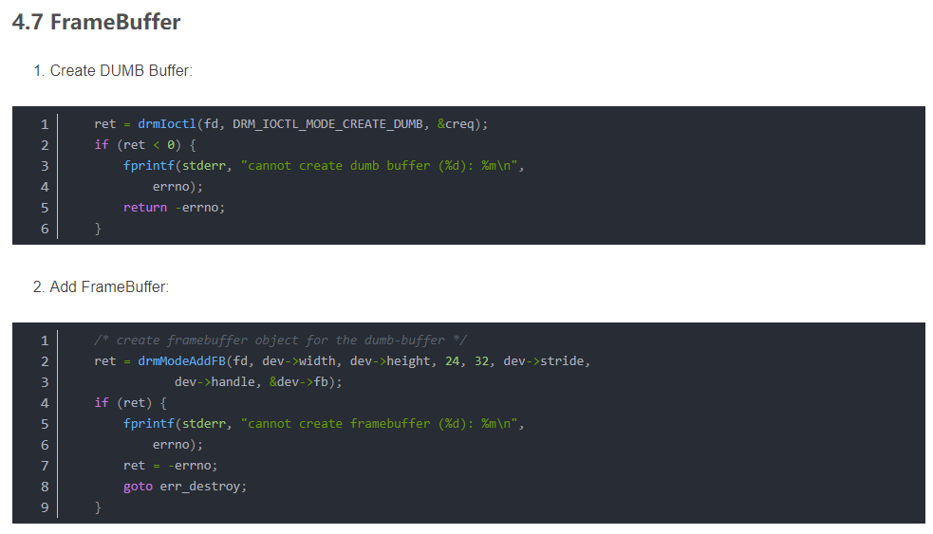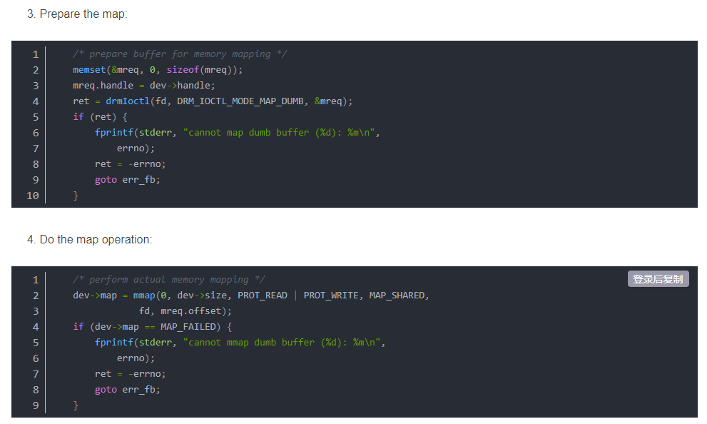

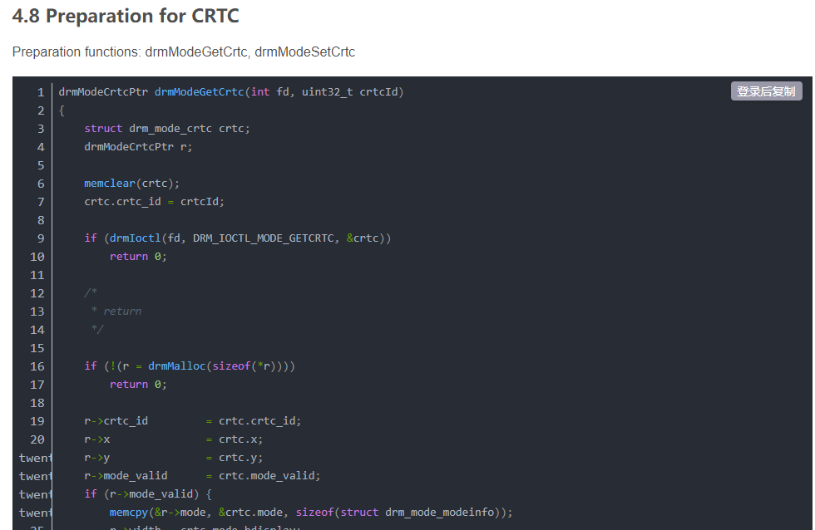

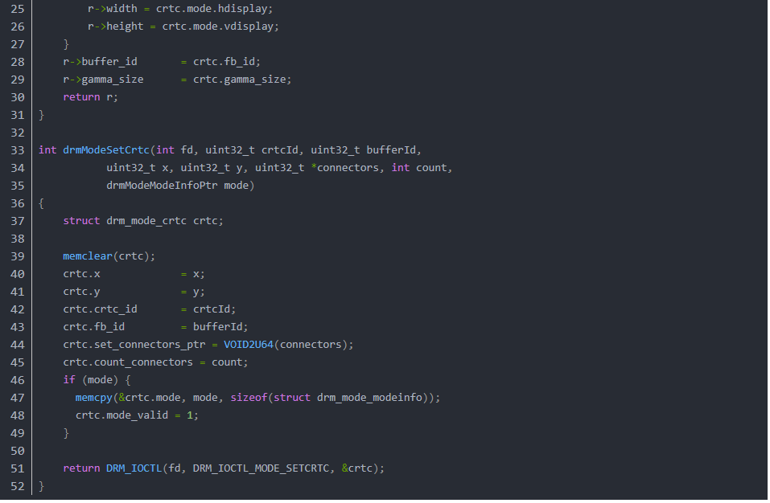

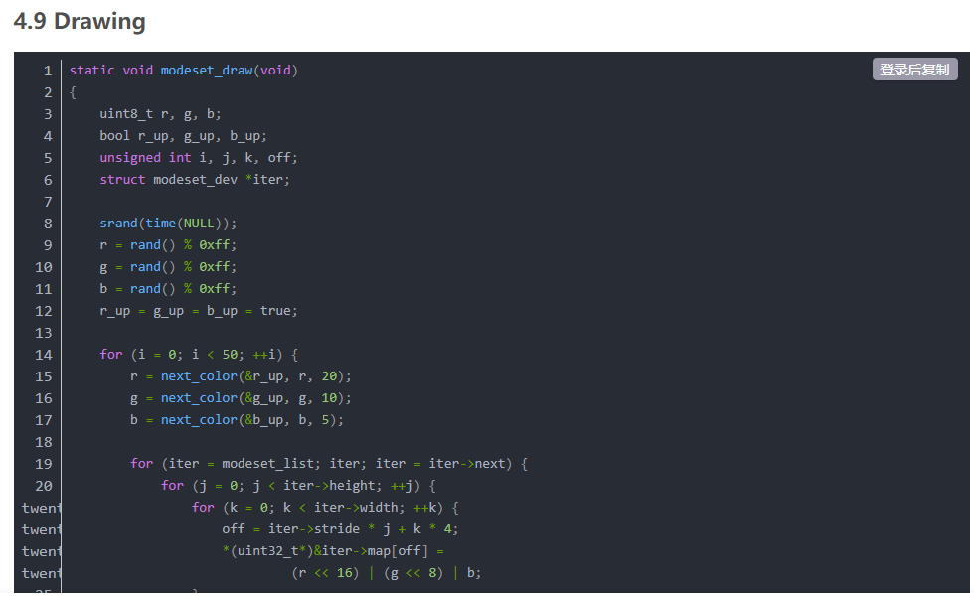

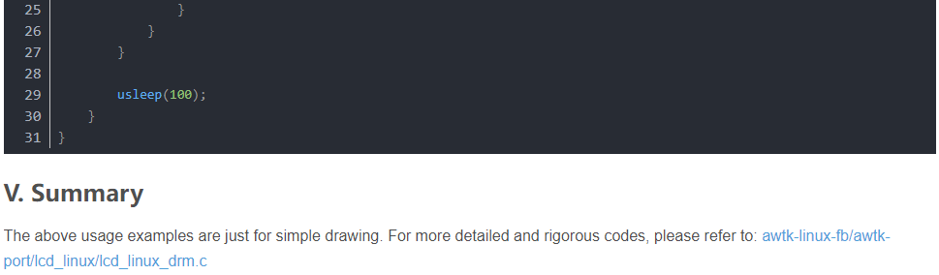

# [RK3399][Android7.1] DRM module introduction in Display

OS: Android 7.1

Board: Firefly-RK3399

Kernel: v4.4.55

**DRM introduction :**

The full name of DRM is Direct Rendering Manager, which is a device-independent kernel-level driver. The kernel provides direct access to hardware. It was originally designed for PCs to support complex graphics devices, and later used in embedded systems.

PCs generally have graphics cards and have their own video memory, while embedded systems do not.

**DRM composition :**

KMS(Kernel Mode Setting): change resolution and bit depth

DRI (Direct Rendering Infrastructure): Direct access to the hardware interface

GEM (Graphics Execution Manager): memory management

DRM Driver in kernel side: access hardware

**Without DRM, how can embedded systems achieve display and memory management?**

Display: Based on Linux Framebuffer

Multimedia: Based on V4L2

Buffer Manager: Based on ION, PMEM, etc.

**Why choose DRM?**

The community has been maintaining

Provides fine-grained control in the display section

user-space graphic is widely used

Offers a full set of advanced features

**Why not choose FBDEV or V4L2?**

FBDEV: There are fewer community maintainers; features such as overlay hw cursor cannot be provided; developers are encouraged to migrate to DRM/KMS in the future.

V4L2: Mainly used for video module, display module is a bit overkill.

**What are the advantages of DRM?**

Control all hardware devices through a single device node

Generic Access Hardware Interface

General memory management mechanism

**Composition of KMS Framework:**

**Framebuffer, CRTC, Encoder and Connector, and Plane and drm device.**

The location of each module in the framework is as follows:

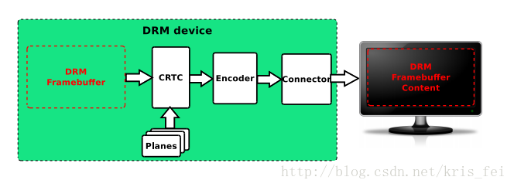

**Framebuffer:**

Memory information such as width, height, bpp, etc.

The code is represented by struct drm\_framebuffer,

which is created in rockchip\_drm\_fbdev\_create()@rockchip\_drm\_fbdev.c.

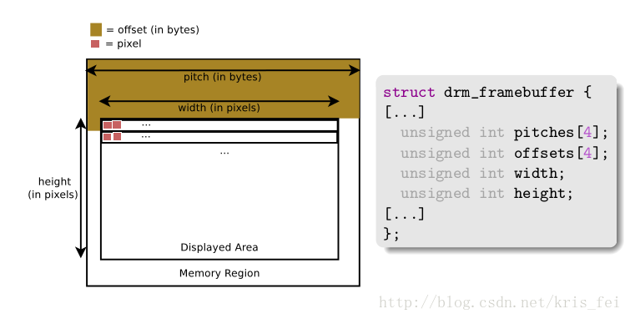

**CRTC:**

It used to represent the CRT controller, which is currently mainly used for display control, such as

the configuration of display timings, resolution, sending the framebuffer content to the display, updating the framebuffer, etc.

It is represented by two structures struct drm\_crtc\_funcs and struct drm\_crtc\_helper\_funcs in the code.

Created in vop\_create\_crtc()@rockchip\_drm\_vop.c.

**Encoder:**

Convert the data into a suitable format and send it to the connector. For example, HDMI requires TMDS information, and the encoder converts the data into the TMDS format required by HDMI.

It is represented by two structures struct drm\_encoder\_funcs and struct drm\_encoder\_helper\_funcs in the code.

Because it has a very close relationship with the connnector, its registration is placed in the driver file of each connector, such as rockchip\_dp\_drm\_create\_encoder()@analogix\_dp-rockchip.c

**Connector:**

Represents a specific external interface, such as edp, hdmi, mipi, etc. It is used to transmit signals to external hardware display devices and detect the access of external display devices.

Represented in the code by struct drm\_connector\_funcs and struct drm\_connector\_helper\_funcs.

There are several driver files, rockchip\_lvds.c, analogix\_dp-rockchip.c, cdn-dp-core.c, dw-mipi-dsi.c, dw\_hdmi-rockchip.c.

The registration of analogix\_dp-rockchip.c is placed in analogix\_dp\_core.c and will be called indirectly through rockchip\_dp\_bind().

Some of the contents of the two modules, Encoder and Connector, overlap, so it is difficult to separate them clearly.

**Planes:**

A Plane represents an image layer, and the final image consists of one or more Planes.

Different types of Planes:

DRM\_PLANE\_TYPE\_PRIMARY: must have, due to display background or image content

DRM\_PLANE\_TYPE\_OVERLAY: Used to display Overlay

DRM\_PLANE\_TYPE\_CURSOR: used to display the mouse

It is represented by struct drm\_plane\_funcs in the code.

Create registration in vop\_plane\_init()@Rockchip\_drm\_vop.c.

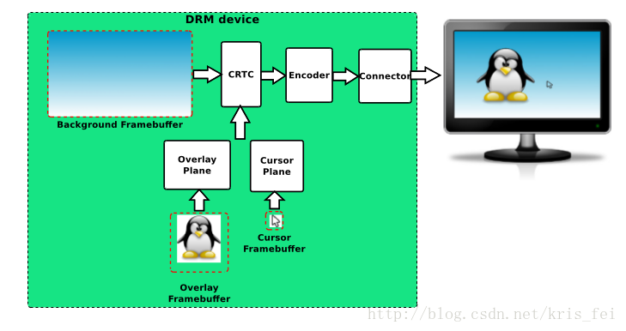

**drm device:**

handles user space requests.

The execution is represented by struct drm\_driver in the code.

Created and registered in rockchip\_drm\_bind()@Rockchip\_drm\_drv.c.

Reference:

brezillon-drm-kms.pdf

DRM Driver Development For Embedded Systems.pdf

# Linux DRM (three) RK platform DRM code analysis- Rockchip

## 1. Overview

I don’t know if you still remember, I have quoted the introduction of DRM in Wiki before, let’s review it again: DRM consists of two parts: one is the subsystem of Kernel, this subsystem implements a layer of framework for hardware [GPU](https://so.csdn.net/so/search?q=GPU&spm=1001.2101.3001.7020) operation package. The second is to provide a libdrm library, which encapsulates a series of APIs for image display. On the whole, it is similar to the Direct Frame Buffer used on Android. Android Kernel takes the framework of FB, and abstracts a FBDEV in HAL for unified management of FB IOCTL. DRM is equivalent to direct centralized processing of graphics devices, and an additional libdrm library is added.

Its overall context is as follows:

# 

# 

# 

Component framework

Before talking about the startup process, let's take a brief look at the Component framework.

Because there are many devices attached to drm, the boot sequence often causes various problems:

* It is entirely possible for a driver to probe deferral while waiting for the preparation of another resource, resulting in an indeterminate order
* The sub device is not loaded, the main device is loaded, causing the device to fail to work
* The sub-devices may have a timing relationship with each other, and the loading order may be uncertain. Sometimes the device can work, and sometimes it cannot work.
* Now the kernel is compiled with multi-threading, and the order before and after compilation will also affect the loading order of the driver.

At this time, a unified management mechanism is needed to integrate all devices and load them in a unified order. Display-subsystem is officially used to solve this problem and depends on the Component driver. Through this driver, all devices can be Add them together in the form of components, and after all components are loaded, bind/unbind them together.

Code path: drivers/base/component.c

The following is the main logic of the Component in the rockchip drm master probe stage. In order to reduce the space, the irrelevant code has been removed:

# 

# 

# 

Based on Component mining, in the probe stage:

* Parse the information of each device in dts
* Add to Component match list
* After the device is loaded, the master device binds

### **RK DRM Device Driver**

**device tree**

display\_subsystem: display-subsystem {undefined  
        compatible = "rockchip,display-subsystem";  
        ports = <&vopl\_out>, <&vopb\_out>;  
        status = "disabled";  
};

- compatible: Should be "rockchip, display-subsystem"  
- ports: Should contain a list of phandles pointing to display interface port of vop devices. vop definitions as defined in  
kernel/Documentation/devicetree/bindings/display/rockchip/rockchip-vop .TXT

**drm driver**

code path:

drm\_driver rockchip\_drm\_driver = struct {static undefined  
.driver\_features = DRIVER\_MODESET | DRIVER\_GEM |  
DRIVER\_PRIME | DRIVER\_ATOMIC |  
DRIVER\_RENDER,  
.preclose = rockchip\_drm\_preclose,  
.lastclose = rockchip\_drm\_lastclose,  
.get\_vblank\_counter = drm\_vblank\_no\_hw\_counter,  
.Open = rockchip\_drm\_open,  
.postclose = rockchip\_drm\_postclose,  
.enable\_vblank = rockchip\_drm\_crtc\_enable\_vblank,  
.disable\_vblank = rockchip\_drm\_crtc\_disable\_vblank,  
.gem\_vm\_ops = &rockchip\_drm\_vm\_ops,  
.gem\_free\_object = rockchip\_gem\_free\_object,  
.dumb\_create = rockchip\_gem\_dumb\_create,  
.dumb\_map\_offset = rockchip\_gem\_dumb\_map\_offset,  
.dumb\_destroy = drm\_gem\_  
= drm\_gem\_prime\_handle\_to\_fd .prime\_handle\_to\_fd,  
.prime\_fd\_to\_handle = drm\_gem\_prime\_fd\_to\_handle,  
.gem\_prime\_import = drm\_gem\_prime\_import,  
.gem\_prime\_export = drm\_gem\_prime\_export,  
.gem\_prime\_get\_sg\_table = rockchip\_gem\_prime\_get\_sg\_table,  
.gem\_prime\_import\_sg\_table = rockchip\_gem\_prime\_import\_sg\_table,  
.gem\_prime\_vmap = rockchip\_gem\_prime\_vmap,  
.gem\_prime\_vunmap = rockchip\_gem\_prime\_vunmap,  
.gem\_prime\_mmap = rockchip\_gem\_mmap\_buf,  
#ifdef CONFIG\_DEBUG\_FS  
.debugfs\_init = rockchip\_drm\_debugfs\_init,  
.debugfs\_cleanup = rockchip\_drm\_debugfs\_cleanup,  
#endif  
.ioctls = rockchip\_ioctls,  
.num\_ioctls = ARRAY\_SIZE(rockchip\_ioctls),  
.fops = &rockchip\_drm\_driver\_fops,  
.name = DRIVER\_NAME,  
.desc = DRIVER\_DESC,  
.date = DRIVER\_DATE,  
.major = DRIVER\_MAJOR,  
.minor = DRIVER\_MINOR,  
};

**vop driver**

code path:

drivers/gpu/drm/rockchip/rockchip\_drm\_vop.c

drivers/gpu/drm/rockchip/rockchip\_vop\_reg.c

Structure:

struct vop;  
// vop drives the root structure, a vop corresponds to a struct vop structure

struct vop\_win;  
// Describe layer information, a hardware layer corresponds to a struct vop\_win structure

Register read and write: In order to be compatible with various versions of vop, the vop driver uses a register-level abstraction, and a structure is used to save the abstract relationship, so that the theme logic only needs to operate the abstract function definition, which is defined by the abstract read-write interface. Write to the real vop hardware according to the abstract relationship.

Example:

static const struct vop\_win\_phy rk3288\_win23\_data = {undefined  
        .enable = VOP\_REG(RK3288\_WIN2\_CTRL0, 0x1, 4),  
}

static const struct vop\_win\_phy rk3368\_win23\_data = {undefined  
        .enable = VOP\_REG(RK3368\_WIN2\_CTRL0, 0x1, 4),  
}

The address distribution of the rk3368 and rk3288 layers is different, but when the structure is defined, different hardware layer bits can be mapped to the same enable function, so that when the vop driver calls VOP\_WIN\_SET(vop, win, enable, 1), Can operate to the real vop register.

### **2.1. Device file cardX**

DRM is in kernel space, which means that user space needs to apply for its services through system calls. However DRM does not define its own system calls. Instead, it follows the "Everything is file" principle and exposes GPU access via the filesystem in the /dev/dri/ directory. DRM will detect each GPU, generate the corresponding DRM device, and create the device file /dev/dri/cardX to connect with the GPU. X is a value from 0-15, the default is Card0.

User-space programs that wish to access the GPU must open this file and communicate with the DRM using ioctls. Different ioctls correspond to different functions of the DRM [API .](https://so.csdn.net/so/search?q=API&spm=1001.2101.3001.7020)

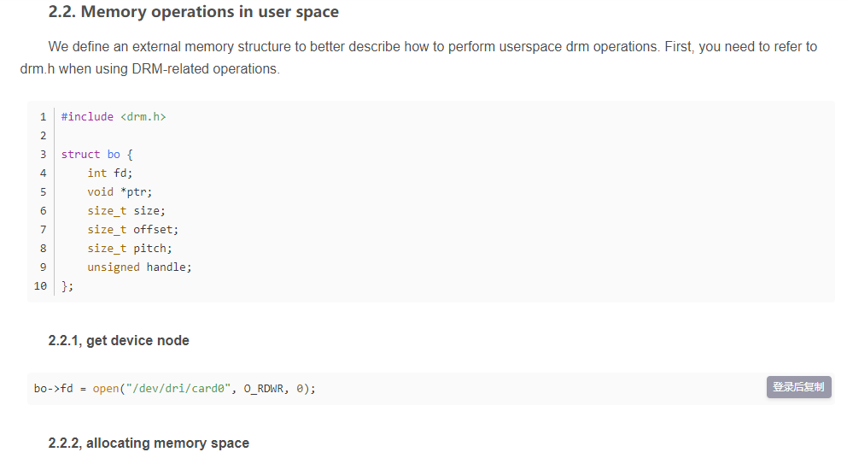

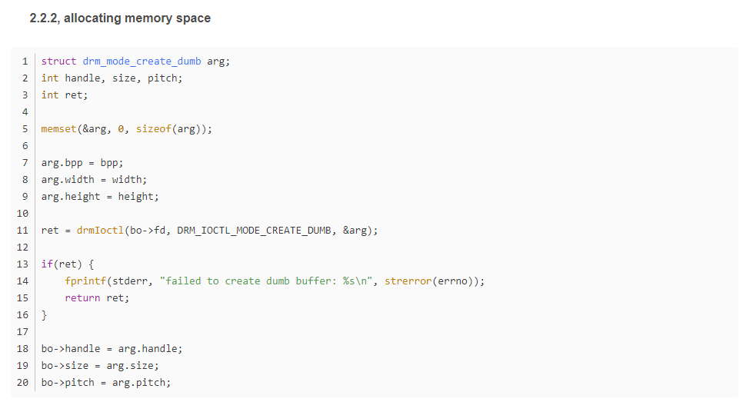

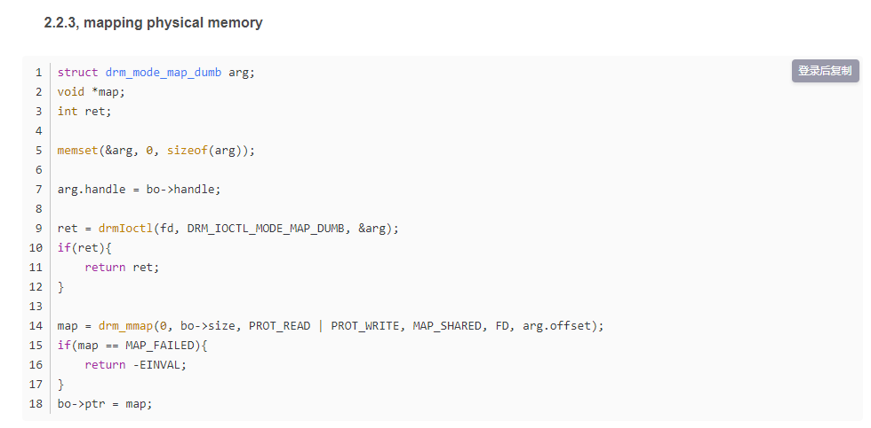

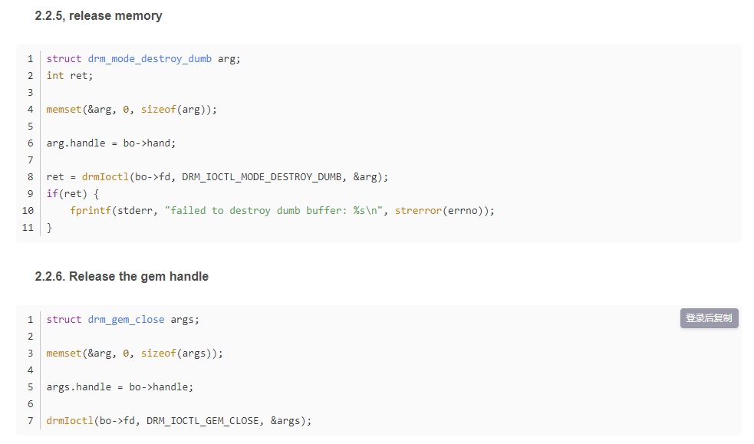

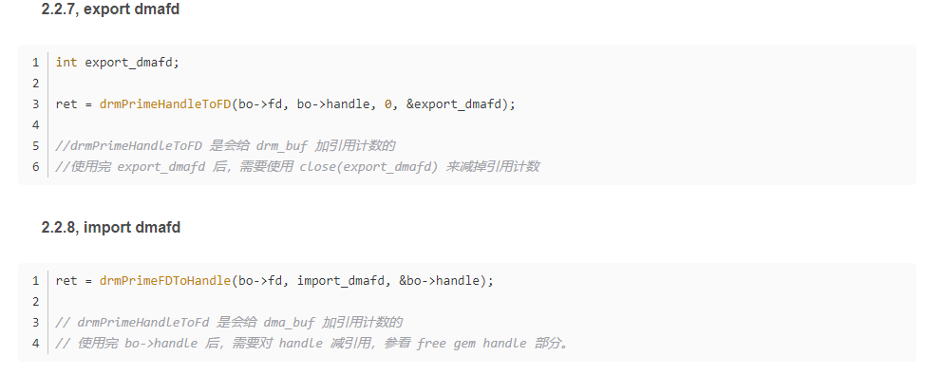

### **2.2, DRM libdrm**

libdrm was created to facilitate the connection between user space and the DRM subsystem. It just provides wrappers (C) for some functions written for each ioctl, exposure, structure of the DRM API. Using the libdrm library not only avoids exposing the kernel interface directly to the user space, but also has common advantages such as code reuse.

### **2.3, DRM code structure**

Divided into two parts: general DRM Core and DRM Driver adapted to different types of hardware.

1. **DRM Core** provides the basic framework that different DRM drivers can register, and provides user space with a minimal set of ioctls with generic, hardware-independent capabilities.
2. **The DRM Driver** implements the hardware-dependent part of the API. It provides implementations of the remaining ioctls not covered by DRM Core, and it can also extend the API to provide additional ioctls. For example, a specific DRM Driver provides some enhanced APIs, and libdrm in user space also needs additional libdrm-driver extensions to use these additional ioctls.

### **2.4. DRM API**

**DRM Core** exports multiple interfaces to user-space applications, so that the corresponding libdrm is packaged into functions for later use.

The interface of the specific device exported by the DRM Driver can be used by the user space through ioctls and sysfs.

### **2.5. DRM-Master and DRM-Auth**

There are several ioctls in the DRM API that are limited to a single process in user space due to concurrency issues. To achieve this restriction, DRM devices are divided into Master and Auth. The above ioctls can only be called by the DRM-Master process. The file handle of the process that opened /dev/dri/cardX will be marked as master, especially the first process that calls the SET\_MASTER ioctl. Processes that are not DRM-Master will return errors when using these restricted ioctls. A process can also give up the Master role through the DROP\_MASTER ioctl to make other processes become Master.

X Servers or other Display Servers are usually the DRM-Master processes for the DRM devices they manage. When the DRM device is started, these Display Servers open the device node and obtain DRM-Master permissions until the device is closed.

For other userspace processes, there is another way to obtain these restricted permissions for DRM devices, which is DRM-Auth. It is an authentication method for DRM devices to prove that the process has obtained permission from the DRM-Master for them to access restricted ioctls.

step:

* The **DRM Client** uses the GET\_MAGIC ioctl to obtain a 32-bit integer token from the DRM device. and passed to the DRM-Master by any means (usually IPC).
* The **DRM-Master** process uses the AUTH-MAGIC ioctl to return the token to the DRM device.
* The device compares the token given by the DRM-Master with the Auth one. If passed, the process file handle is given special permissions.

**The architecture of DRM in the source code (pictured from Mark.Yao):**

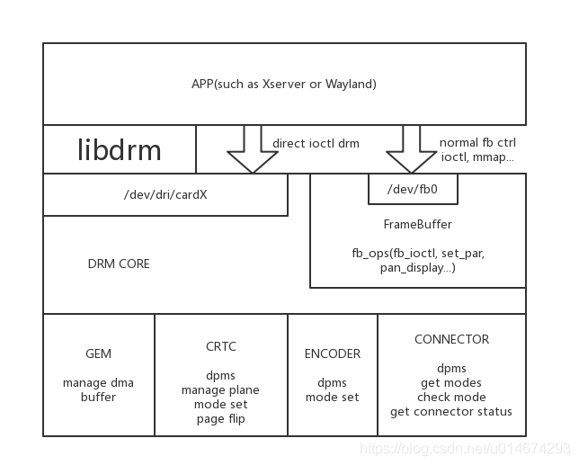

**Use DRM to access Video Card (pictured from Wikipedia):**

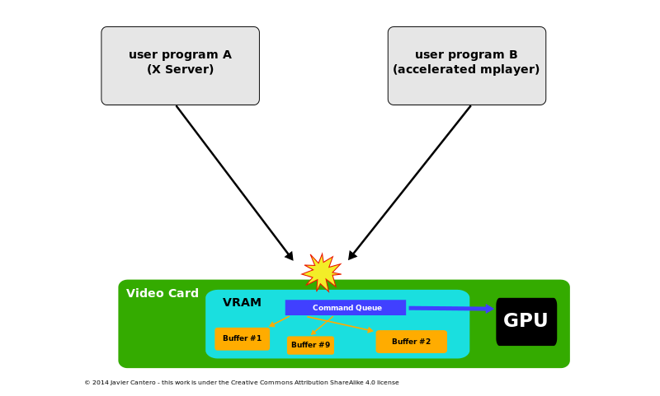

**When there is no DRM, the user space process accesses the GPU, as shown in the figure above.**

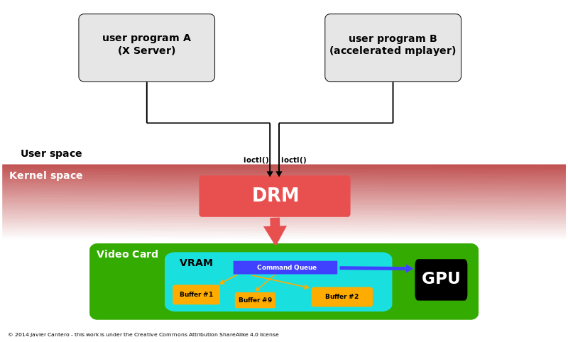

**With DRM, the way the user space accesses the GPU is shown in the figure above.**

# Code analysis of linux drm architecture

**The previous article introduced the architecture of the linux display driver drm, here we review it in a certain order:**

**1 I connect the monitor to the DVI output of the graphics card, this connection is abstracted into Connector**

**2 Drive the Encoder that will assign the DVI signal on the DVI Connector. If it is not assigned, all available encoders will be found on the connector resource**

**3 The encoder is used for image scanning on-site crtc service. The driver may assign crtc to the encoder, or you can find the available crtc from the encoder's possible\_crtc**

**4 crtc scan site to configure the physical memory area fb to display the image**

**5 After the relationship of fb -> crtc -> encoder -> connector is bound, the drawing work has already started, you can write any drawing on fb, and then it will be displayed immediately!**

**6 However, in order to avoid image tearing, you can create multiple fb (buffer) to refresh the drawing by pageFlip operation.**

**7 Of course, there is also a plane specially used for video refresh, and the plane must be bound to crtc to work.**

**Two summary + the use of drm api:**

**api use refer to David Herrmann <dh.herrmann@googlemail.com>'s drm-howto and weston and the modetest program that comes with drm**

**The core configuration of drm api is to bind a crtc relationship fb -> crtc -> encoder -> connector**

**Let's look at the review of "One", why is it in reverse order? Haha, in fact, this is only logical, how to use the api, look down:**

**1 First open the drm driver module, and then get all the resources**

**fd = open("/dev/dri/card0", O\_RDWR | O\_CLOEXEC);**

**drmModeRes　res = drmModeGetResources(fd);**

**What's in res? It tells how many connectors, how many encoders, how many crtcs, and their ids. It's not a complete set at all!**

**2 Start with the connector and follow the trail**

**Get the specific resources of connecotr first**

**drmModeConnector \* conn = drmModeGetConnector(fd, res->connectors[i]);**

**There are two important parts in the conn resource, one is to read out the "modes" of the display through the cable, such as 1920x1080@60, etc. Of course, you have to choose a favorite**

**The other part is that the encoder starts to find the encoder in the order of 2 in a chapter (see the definition of drmModeConnector) :p**

**3 Find a suitable crtc for the encoder**

**Find crtc in the order of 3 in a chapter**

**4 Create fb for crtc**

**The example modetest of drm is very detailed, ARGB can be directly drmModeAddFB, and multi-plane fb can be used drmModeAddFB2**

**5 binding**

**core quad < fb , crtc , conn , mode >**

**int drmModeSetCrtc(int fd, uint32\_t crtcId, uint32\_t bufferId,**

**uint32\_t x, uint32\_t y, uint32\_t \*connectors, int count,**

**drmModeModeInfoPtr mode);**

**6 pageFlip**

**extern int drmModePageFlip(int fd, uint32\_t crtc\_id, uint32\_t fb\_id,**

**uint32\_t flags, void \*user\_data);**

**Remember how to play this.**

**First, poll (drm\_fd) can receive the POLLIN message of drm. There are only two kinds of messages in the message, one is VBLANK, and the other is pageFlip complete**

**Secondly, after receiving the message, you must call drmHandleEvent(drm\_fd , &evctx); to process the message, remember that you must fill in your pageFlip processing function into evctx,**

**What are you doing in the pageFlip　processing function? One frame of pageFlip is over, and of course the next frame of pageFlip is required!**

**7 plane**

**I didn't understand the gameplay of plane. I tried it, using multi-buffer to adjust drmModeSetPlane to change the page to achieve video playback, but I encountered two problems:**

**One is the timing of SetPlane, how to wait for the field synchronization of a display? After reading the code of vblank, I feel that vblank is for the synchronization of one graphics card, but what about I have multiple monitors?**

**The second is the time-consuming operation of SetPlane. My i3 cpu took 22 ~ 23 ms to execute once, which is inexplicable.**

**I thought that the yuv channel of the plane can save resources, but there are two major problems.**

# DRM (Direct Rendering Manager) Learning Introduction

**I have been learning DRM for more than a year. Due to the complex architecture , large amount of code, and few domestic references, it is difficult for beginners to learn. Therefore, I decided to share my learning experience with everyone, hoping to be helpful to the students who are learning DRM, and to exchange experience at the same time.**

**Since I am only responsible for the Display driver in my work, the DRM learning experience I share is limited to the Display part. I can't do anything about the GPU part. If you have relevant experience to share, please let me know in the message. I will visit often. Your blog, we all learn from each other.**

**DRM**

**DRM is the current mainstream graphics display framework of Linux. Compared with the FB architecture, DRM is more adaptable to the current increasingly updated display hardware. For example, FB natively does not support multi-layer synthesis, does not support VSYNC, does not support DMA-BUF, does not support asynchronous update, does not support fence mechanism, etc., and DRM natively supports these functions. At the same time, DRM can manage GPU and Display drivers in a unified manner, making the software architecture more unified and facilitate management and maintenance.**

**DRM is divided into modules and can be simply divided into 3 parts: , ,libdrmKMSGEM**

# insert image description here

**libdrm**

**It encapsulates the underlying interface and provides a common API interface to the upper layer, mainly encapsulating various IOCTL interfaces.**

**KMS**

**Kernel Mode Setting, the so-called Mode setting, is actually two things -** Update screen and set display parameters.

**Update the screen : display the switching of buffers, the composition method of multiple layers, and the display position of each layer.**

**Set display parameters : including resolution, refresh rate, power state (sleep wakeup), etc.**

**GEM**

**The Graphic Execution Manager is mainly responsible for the allocation and release of the display buffer, and it is also the only place where the GPU uses DRM.**

**fundamental element**

**There are many elements involved in the DRM framework, which are roughly as follows:**

**KMS: , , , , , , GEM: , ,CRTC, ENCODER, CONNECTOR, PLANE FB VBLANK property**

**DUM BPRIME fence**

# insert image description here

# 

**Catalog (continuously updated)**

**This blog will be used as a directory summary of my DRM learning tutorial. In the future, I will share the learning process of the above knowledge points with you in the form of sample code, and constantly update the directory link, so stay tuned!**

**Simplest DRM application (single-buffer)**

**Simplest DRM application (double-buffer)**

**Simplest DRM application (page-flip)**

**Simplest DRM application (plane-test)**

**Advanced DRM application (Property)**

**DRM Application Advanced (atomic-crtc)**

**Advanced DRM application (atomic-plane)**

**Development History of DRM (Direct Rendering Manager)**

**DRM Driver Development (Beginning)**

**DRM Driver Development (VKMS)**

**About the origin of the names of DUMB and PRIME in DRM**

**DRM GEM driver development (dumb)**

**Detailed explanation of DRM driver mmap: (1) Preliminary knowledge**

**Detailed explanation of DRM driver mmap: (2) CMA Helper**

**LWN Translation: Introduction to Atomic Mode Setting Design (Part 1)**

**LWN translation: Introduction to Atomic Mode Setting Design (Part 2)**

**Translation: Mainline Explicit Fencing**

**dma-buf series:**

**dma-buf from shallow to deep (1) - the simplest dma-buf driver**

**dma-buf from shallow to deep (two) - kmap / vmap**

**dma-buf from shallow to deep (three) - map Attachment**

**dma-buf from shallow to deep (4) —— mmap**

**dma-buf from shallow to deep (5) —— File**

**dma-buf from shallow to deep (6) —— begin / end cpu\_access**

**dma-buf from shallow to deep (7) — — alloc page version**

**dma-buf from shallow to deep (8) — ION simplified version**

**LWN translation: DMA-BUF cache handling: Off the DMA API map (part 1)**

**LWN translation: DMA-BUF cache handling: Off the DMA API map (part 2)**

**References**

**Wiki: Direct Rendering Manager**

**wowotech: Linux graphic subsystem(2)\_DRI introduction**

**Boris Brezillon: The DRM/KMS subsystem from a newbie's point of view**

**Line·Piaoling Blog Park: Graphics System and AMD R600 Graphics Programming in Linux Environment (1)**

**Younix Dirty Sheep CSDN Blog: Linux DRM (2) Basic Concepts and Features**

# Simplest DRM application (single-buffer)

**In the previous DRM (Direct Rendering Manager) learning introduction, we learned the basic concepts and basic elements of DRM. Starting from this article, I will share with you the entire learning process of learning DRM-driven development in the form of sample code.**

**Before learning DRM driver, you should first understand how to use DRM driver. The following uses pseudo code to briefly introduce how to write a simplest DRM application.**

**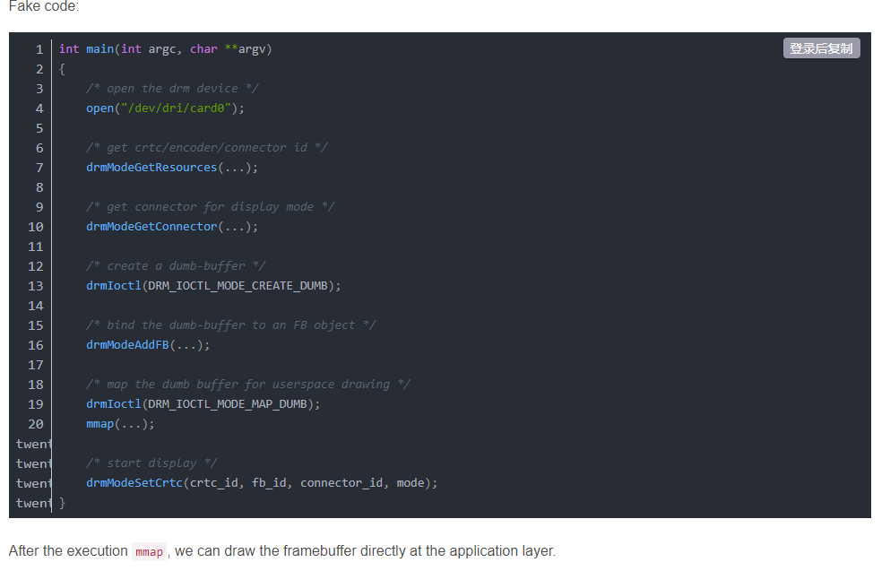**

**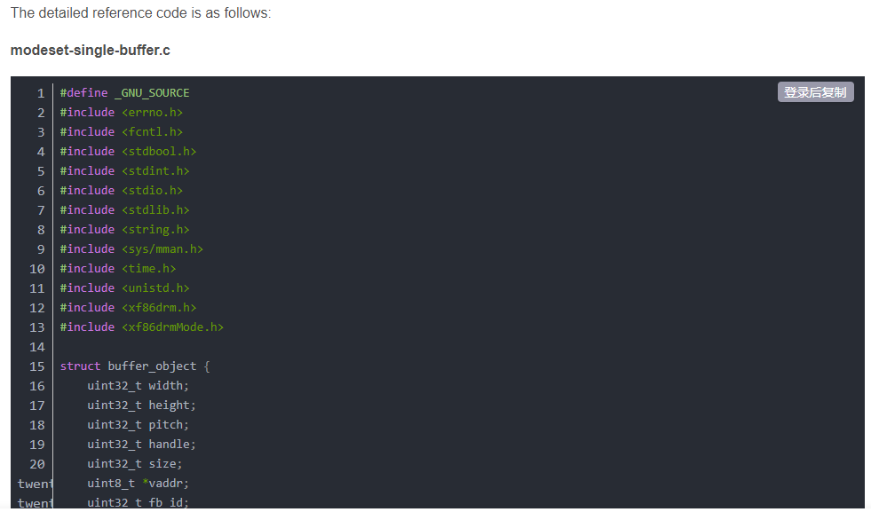**

**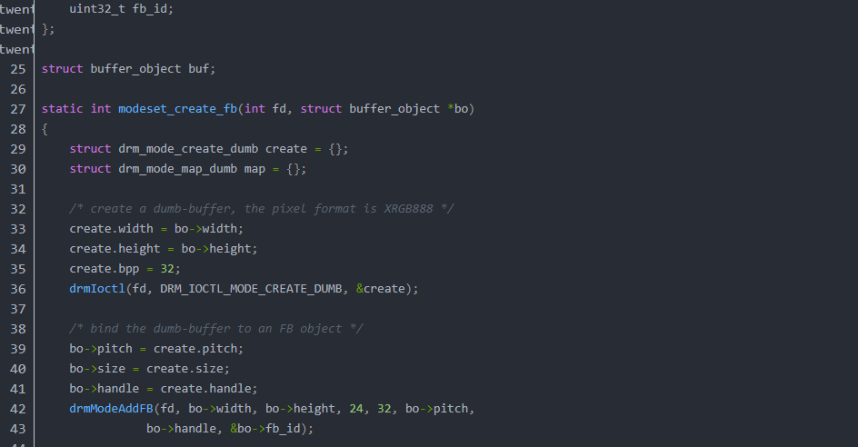**

**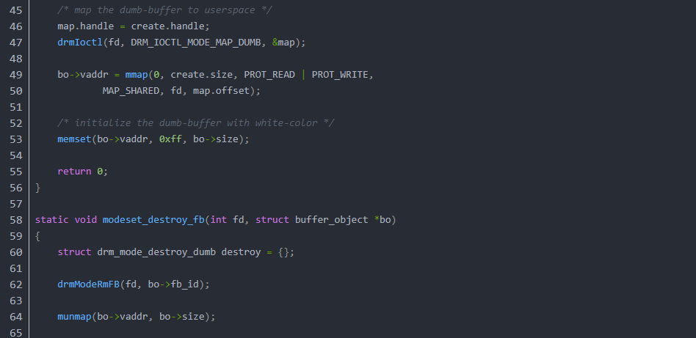**

**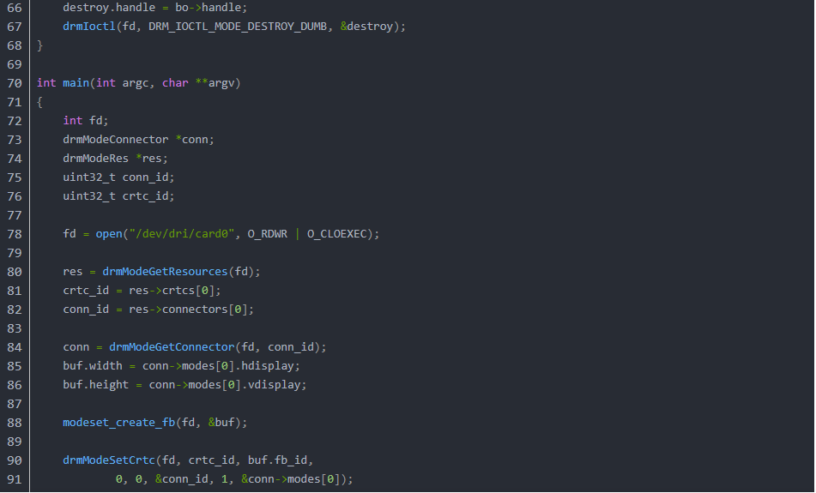**

**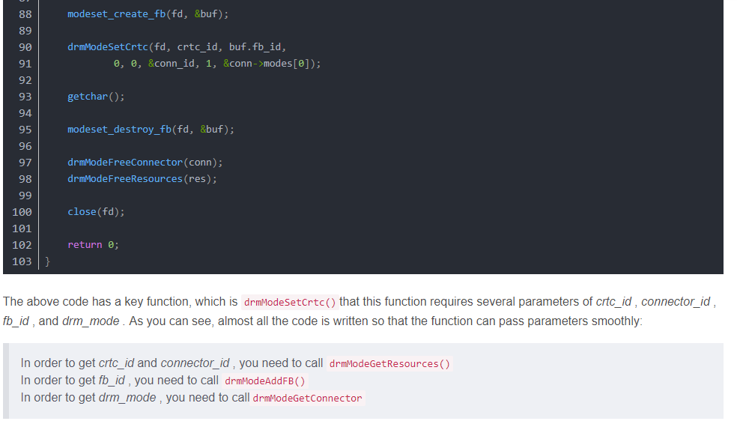**

**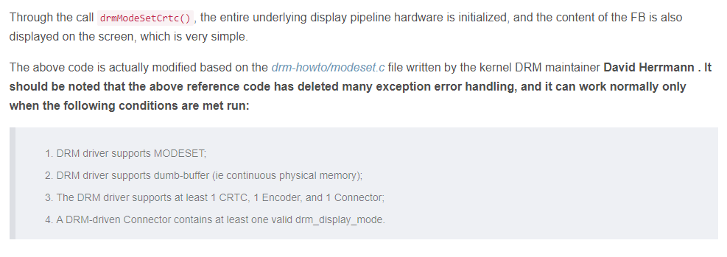**

# Simplest DRM application (double-buffer)

**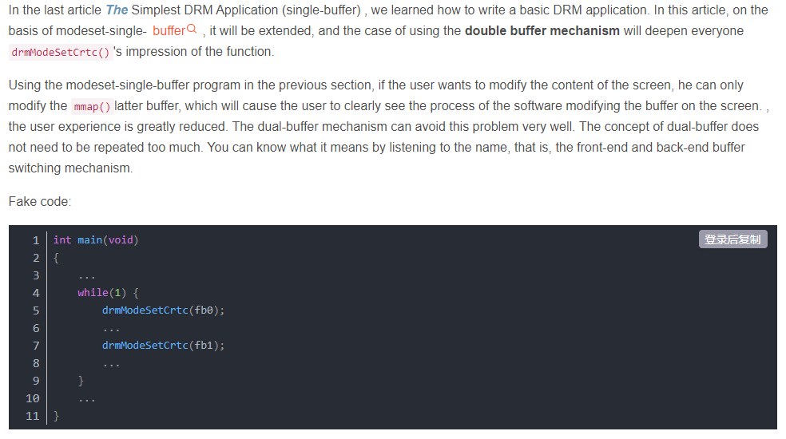**

**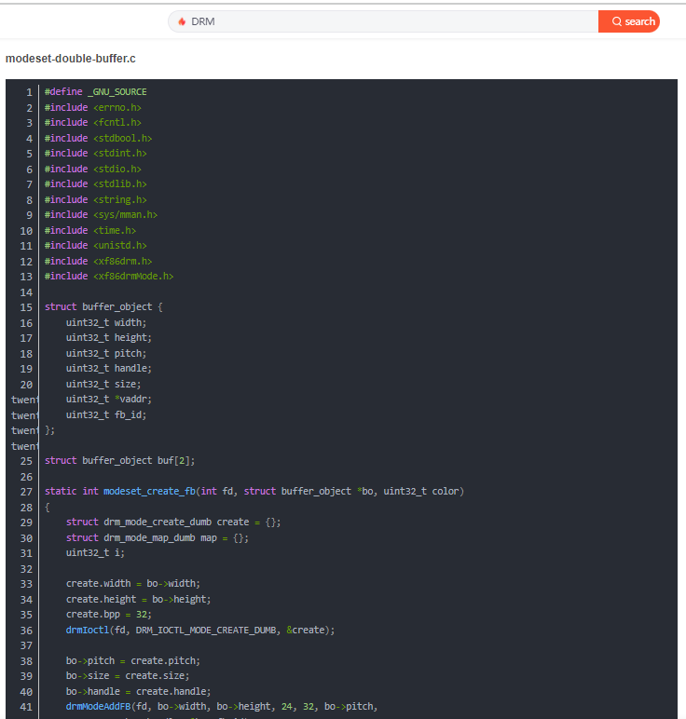**

**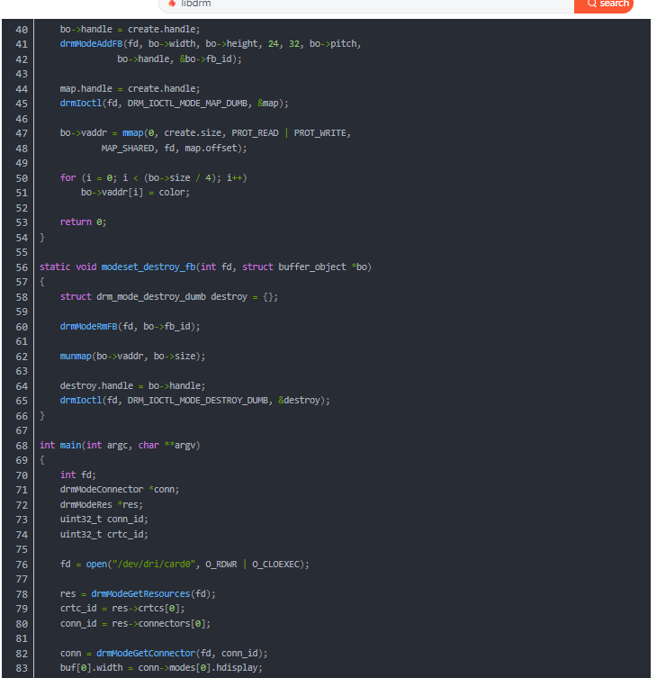**

**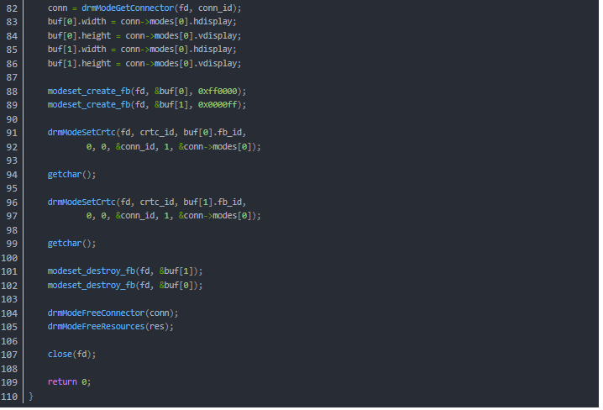**

**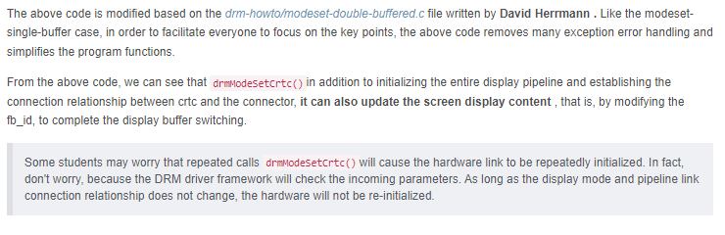**

**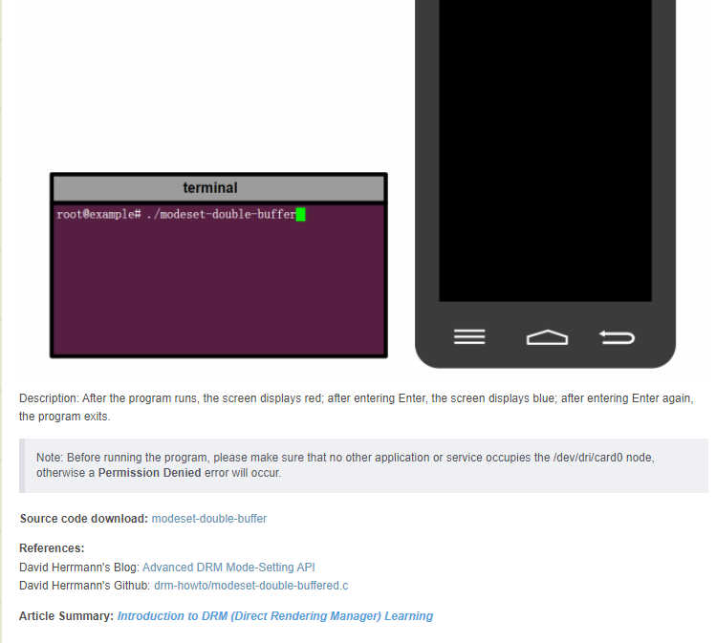**

# 最简单的DRM应用程序 （page-flip）

In the previous article The Simplest DRM Application (double-buffer), we learned about an important interface drmModeSetCrtc() for DRM to update images. In this article, we will learn another important brush interface of DRM: drmModePageFlip().

The function of drmModePageFlip() is also used to update the display content, but the biggest difference between it and drmModeSetCrtc() is that drmModePageFlip() will only wait until VSYNC arrives before actually executing the framebuffer switching action, while drmModeSetCrtc() will execute the framebuffer immediately Toggle action. Obviously, drmModeSetCrtc() can easily cause tear effects on some hardware, while drmModePageFlip() does not.

Since drmModePageFlip() itself is based on the VSYNC event mechanism, the underlying DRM driver must support VBLANK events.

**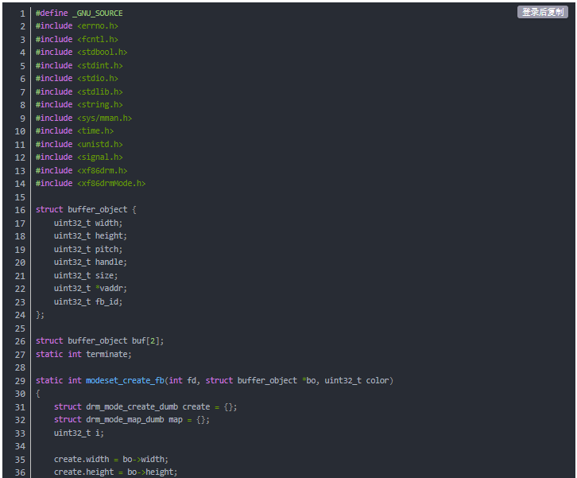**

**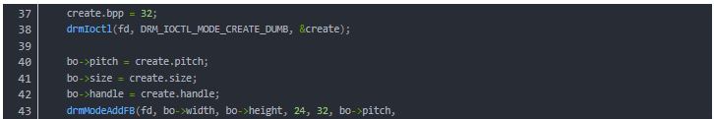**

**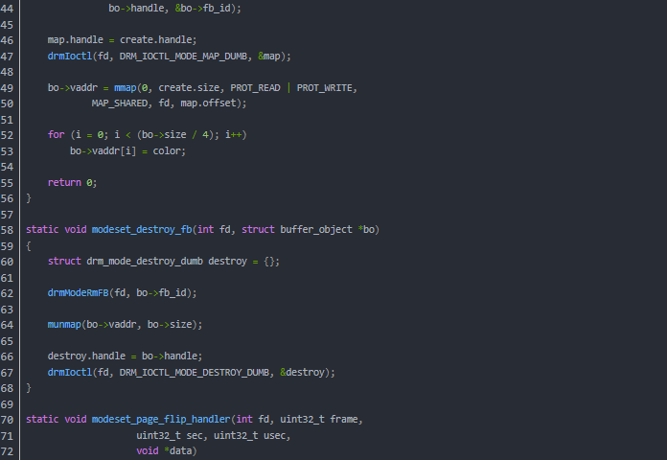**

**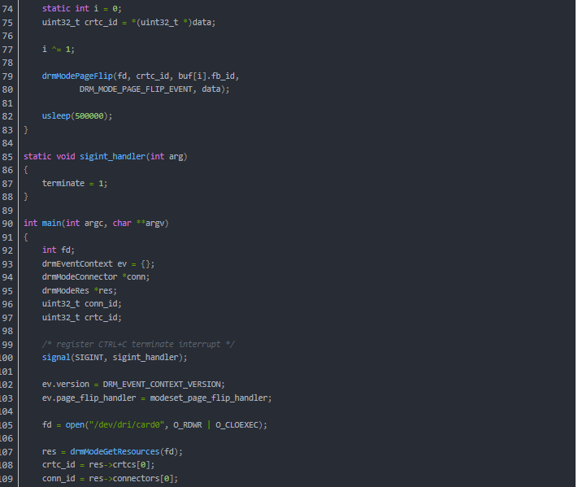**

**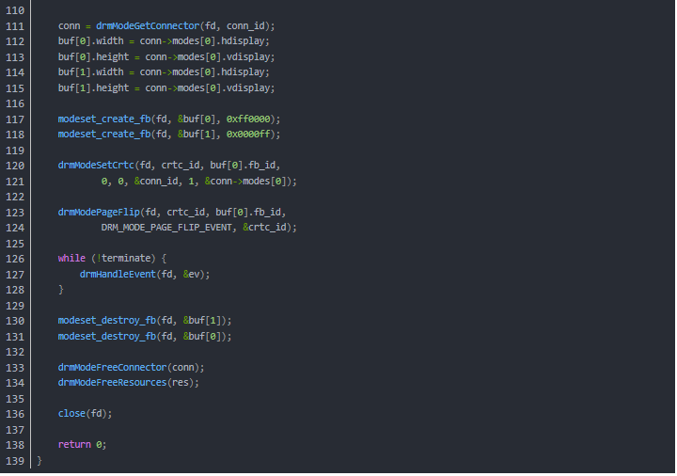**

As can be seen from the above code, to use drmModePageFlip(), you must rely on the drmHandleEvent() function, which internally waits for the underlying driver to return the corresponding vblank event in a blocking form to ensure synchronization with VSYNC. It should be noted that drmModePageFlip() is not allowed to be called multiple times within a VSYNC cycle, otherwise only the first call is valid, and the subsequent calls will return -EBUSY error (-16).

# 

# Simplest DRM application (plane-test)

**In the previous article The simplest DRM application (page-flip) , we learned the drmModePageFlip()usage. In the earlier two articles, we also learned how drmModeSetCrtc()to use it. However, these two interfaces can only display the content of the framebuffer in full screen. How can only a part of the content of the framebuffer be displayed on the screen? In this article, we will learn another important brushing interface of DRM: drmModeSetPlane().**

**Before learning this function, let's first understand, what is Plane? In the opening DRM (Direct Rendering Manager) learning introduction article, I briefly described the concept of Plane, that is, the hardware layer . Today, we will take a closer look at the concept of Plane.**

**The Plane in DRM and the plane in the YUV/YCbCr graphics format we often say are completely different concepts. The plane in the YUV graphics format refers to the arrangement of image data in memory. Generally, the Y channel occupies a continuous memory block, and the UV channel occupies another continuous memory block. We call it YUV-2plane (also called YUV 2 plane). plane), which belongs to the software level. The Plane in DRM refers to a single hardware layer module used for multi-layer synthesis in the Display Controller, which belongs to the hardware level. Do not confuse the two concepts.**

**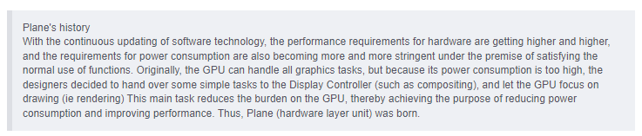**

**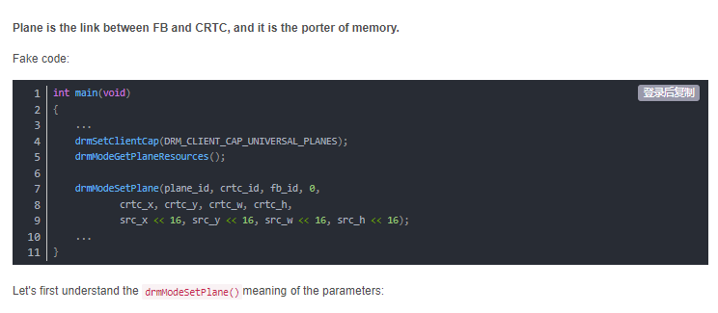**

**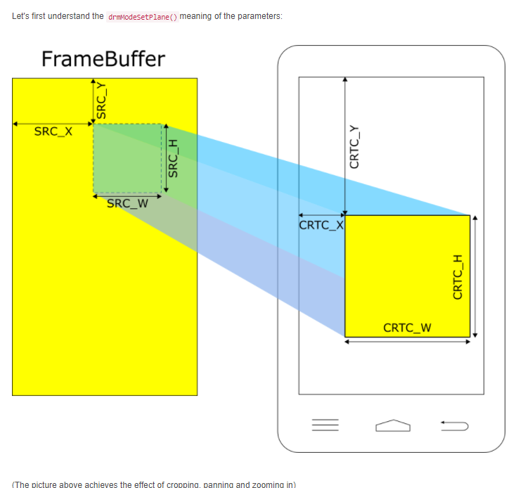**

**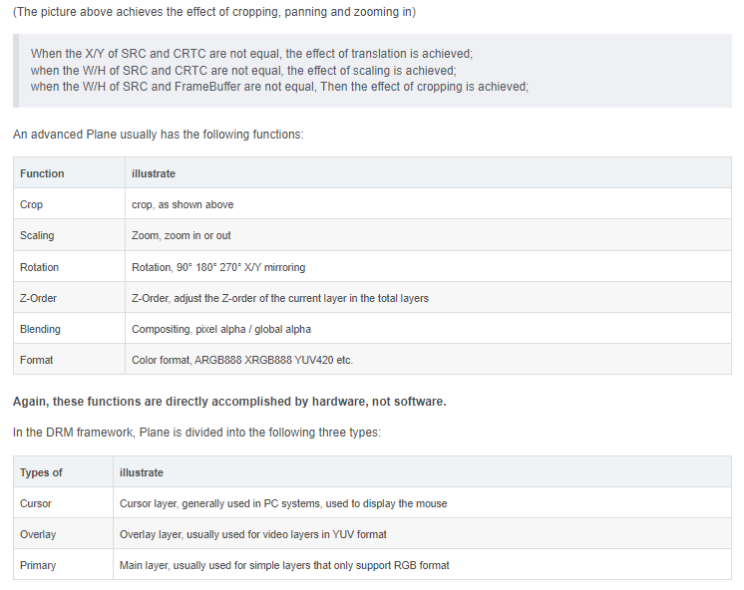**

**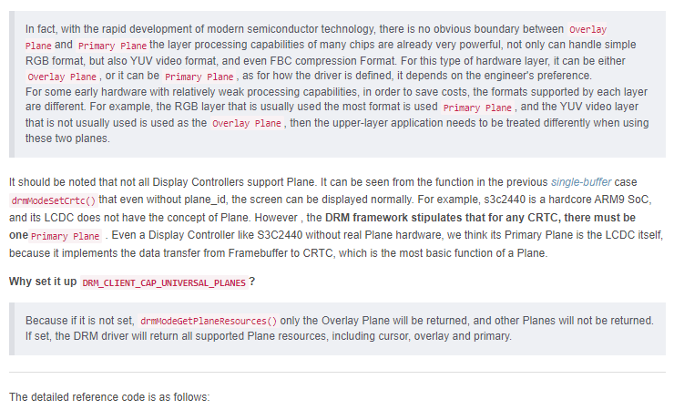**

**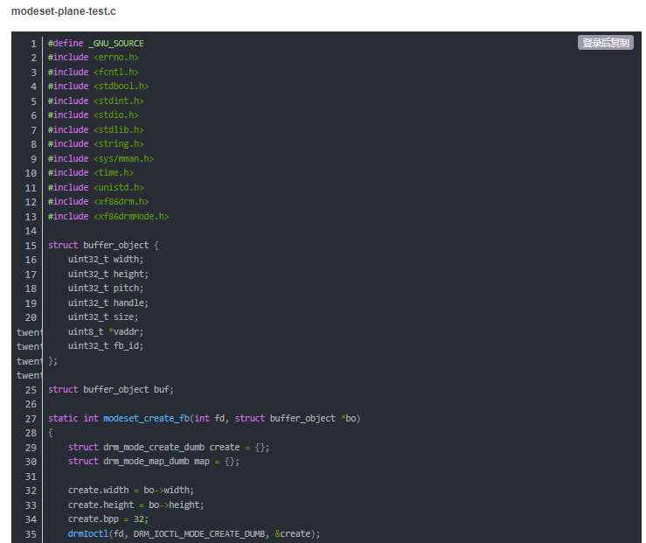**

**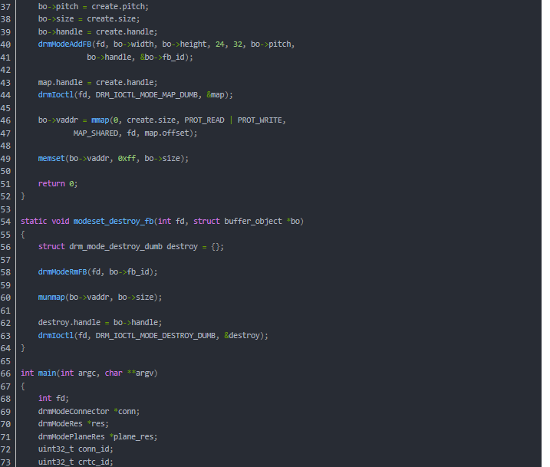**

**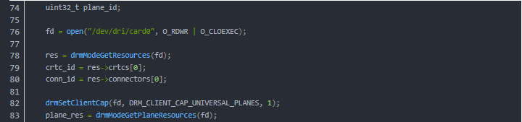**

**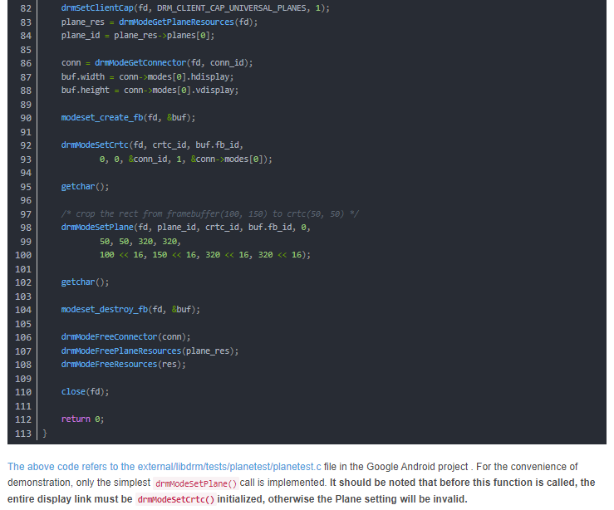**

**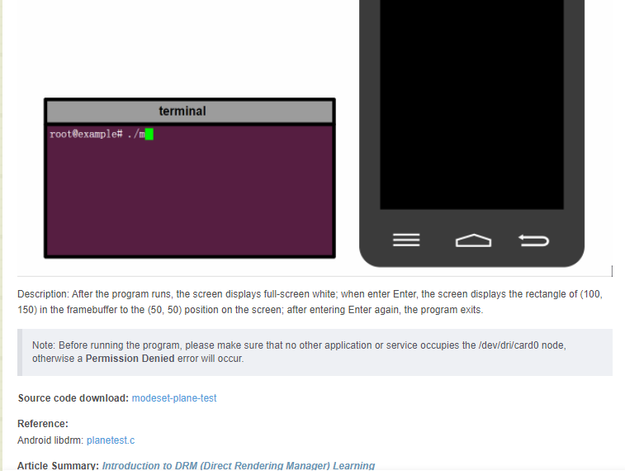**

# Advanced DRM application (Property)

**foreword**

**Through the previous articles in the "The Simplest DRM Application" series, we learned how to write a basic DRM application. However, the interfaces used by these programs have already been marked as Legacy (outdated) interfaces in today's DRM architecture , and currently DRM mainly recommends the use of Atomic (atomic) interfaces. I will focus on the Atomic interface in the next article. This article mainly introduces the basic elements that Atomic operations must rely on, Property .**

**Property**

**The so-called Property, in fact, is to extract the parameters passed in by the legacy interface of the previous articles separately and make them into independent global properties. By setting these property parameters, the setting of display parameters can be completed.**

**A brief summary of the structure of Property is mainly composed of three parts: name, idand value. where idis the globally unique identifier of the property in the DRM framework.**

**The benefits of using the property mechanism are:**

**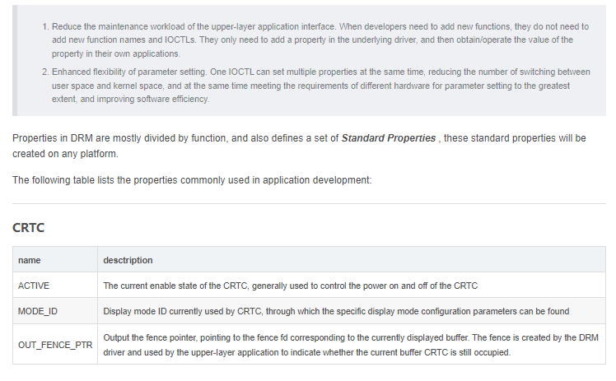**

**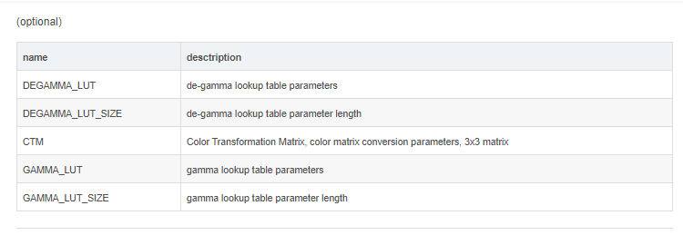**

**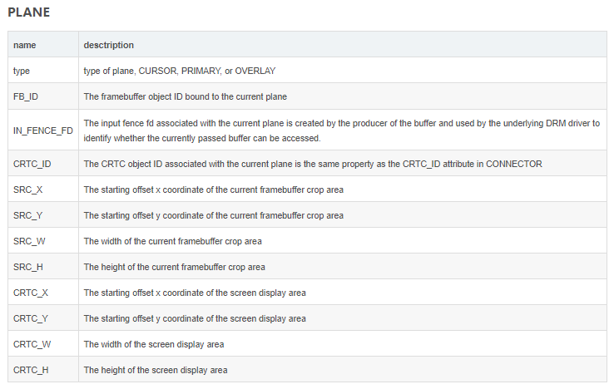**

**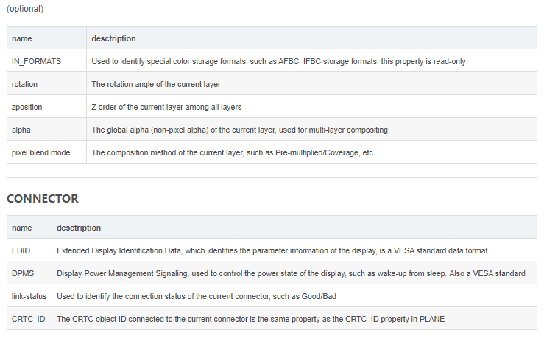**

**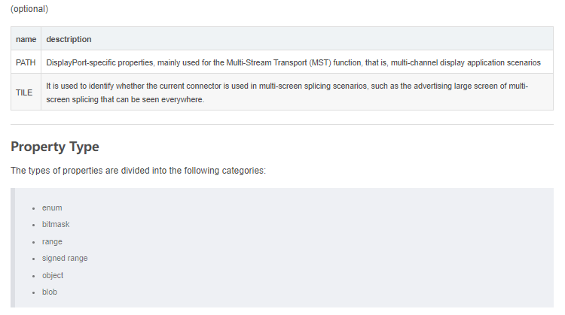**

**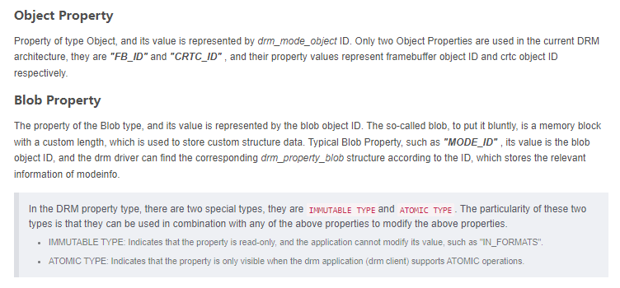**

**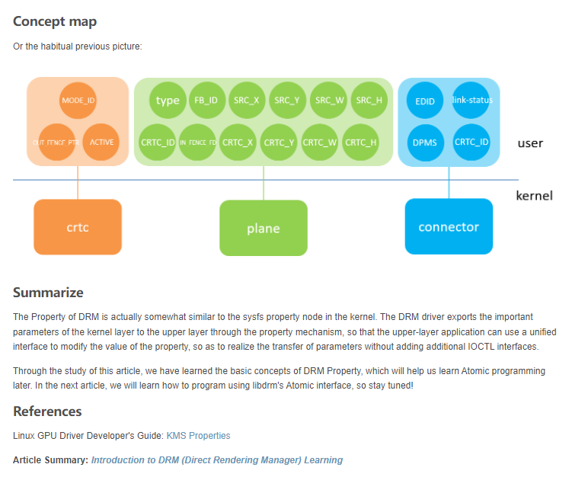**

# DRM Application Advanced (atomic-crtc)

**foreword**

**In the last article "Advanced DRM Application (Property)" , we learned the basic concepts and functions of Property. In this article, we will learn how to operate these Properties, that is, the usage of the libdrm Atomic interface.**

**Atomic**

**Why is it called "Atomic Commit"?**

**When beginners come into contact with DRM for the first time, they will always wonder why the developers named Atomic in the first place. There is a more detailed explanation of this term on the Wiki. If you are interested, you can get the link to view it through the references at the end of this article. Here I briefly summarize it in vernacular: this commit operation will either succeed or keep the original state unchanged. That is, if the operation fails in the middle, those configurations that have taken effect need to be restored to the previous state, as if the commit operation has not occurred. This is the meaning of Atomic.**

**The word Commit is used because this operation may modify multiple parameters. After these parameters are modified, an operation request is initiated at one time, which is somewhat similar to the meaning of "submitting" materials after filling out the form.**

**How to operate property?**

**In the last article, we learned about the basic structure of Property, namely name, idand value. Therefore, it is very simple to operate the property. Obtain the property by name , operate the property by id , and modify the value of the property by value. The application interface to complete these operations is the Atomic interface provided by libdrm.**

**First pass drmModeGetProperty()to get the relevant information of the property, then pass drmModeAtomicAddProperty()to modify the value of the property, and finally pass drmModeAtomicCommit()to initiate the real modification request.**

**Why set DRM\_CLIENT\_CAP\_ATOMIC ?**

**As introduced in the previous article "Advanced DRM Application (Property)" , all DRM\_MODE\_PROP\_ATOMICmodified properties are visible only when the drm application supports Atomic operations, otherwise the property is invisible to the application. Therefore, by setting DRM\_CLIENT\_CAP\_ATOMICthis flag, the DRM driver is told that the application supports Atomic operations.**